Law 435C.001 | Personal Injury Advocacy | 2023 Term 2
Professors:  MARC KAZIMIRSKI and SANDRA KOVACS | Tel: (604) 681-9344  Email: mak@kazlaw.ca  Email: sk@kazlaw.ca  Office: 1900-570 Granville Street, Vancouver BC | Mondays 5:00 – 8:00 pm  UBC Faculty of Law  Room 121

WEEK SEVEN: Experts
- TEACHING OBJECTIVES & OVERVIEW
The goal of this week’s class is to learn how to select, instruct, prepare, object to, and cross-examine expert witnesses in personal injury actions.
Readings:
- White Burgess Langille Inman v. Abbott and Halliburton Co. 2015 SCC 23
- Maras v. Seemore, 2014 BCSC 1109
- Crawford v. Osuteye, 2019 BCSC 2336
- Uy v. Dhillon, 2019 BCSC 1136 (paras. 14-21)
- T.S. v. Gough, 2022 BCSC 264
  - Transcript of Dr. Sobey’s evidence at trial – Appendix A
  - Closing Argument re: Dr. Sobey – Appendix B

- EXPERT OPINION GENERALLY
- An expert’s function is to provide the trier of fact with ready-made inferences which the judge and jury, due to the technical nature of the facts, are unable to formulate (Justice Dickson, R v Abbey, [1982] 2 SCR 24 at page 42)
- A court receives expert opinion to assist its understanding of evidence which is beyond the experience and knowledge of the trier of fact
- The expert is asked to assist the court with the technical analysis of certain facts and to provide the court with an unbiased and objective opinion regarding the inference and conclusions arising from these facts
- Expert opinion evidence is more often than not required to prove the true extent of a claimant’s injuries and losses, because a medical-legal expert can comment upon the claimant’s diagnoses, prognoses (will the injuries resolve or are they permanent?), disability (lost earning capacity and lost homemaking capacity), and provide recommendations for treatment (cost of future care).
- Expert opinion evidence is also required to prove a breach of the standard of care in certain kinds of claims, most notably medical malpractice actions or other professional negligence actions. In the absence of a critical opinion from a professional similarly qualified to the defendant, the action will fail.
- Note that in some cases, the court does not require standard of care opinion. See, for example, Uy v. Dhillon, supra, where Marzari, J. noted that she does not require standard of care opinion evidence with regard to commercial truck driving where the negligence alleged is common to all motor vehicle operators.
- SELECTING THE RIGHT EXPERT
- A properly qualified expert must be shown to have acquired some special knowledge through study or experience in respect of what he or she intends to testify on.
- When selecting an expert, it is important to look at the expert’s history before the courts. You may have found the right expert in terms of qualifications, but if he or she carries baggage into the case then it might be a real problem – you must look at their history as an expert before the courts with several questions in mind:

  - Have they been well-received?
  - Have they previously been labelled an advocate?
- If yes to the questions of advocacy:

  - How long ago was the adverse treatment?
  - Have the findings or allegations been reversed or addressed in later appearances before the court?
- ICBC most often uses orthopedic surgeons instead of physiatrists to opine upon soft tissue injuries. There is a reason for this and it has not gone unnoticed by the court. Mr. Justice Saunders’ comments in Khudabux v. McClary, 2016 BCSC 1886 (CanLII), at paras. 92-93, a case where ICBC hired an orthopedic surgeon as per its usual practice:
There is a tendency common to many orthopaedic surgeons who provide expert opinion reports in soft tissue injury cases before this court to express their opinions without qualification – specifically, without acknowledging the extent to which their opinions are shaped by or restricted to the narrow field of their own expertise. In the result, many such reports come before this court that, in substance, say “I have examined this patient, and nothing is wrong with them,” when what is really meant is, “I have examined this patient, and I am unable to diagnose any orthopaedic injury”. Expert witnesses who provide opinions in such stark terms without explicitly stating the limitations of their opinion may, if their opinions contrast with complaints of pain and suffering that are found to be genuine, and are at odds with contrary opinion evidence from another medical expert, risk creating confusion. They may also leave themselves vulnerable to a finding of bias if the unstated limitations of their opinions are not drawn out at trial.
These risks should be avoided through counsel having, in the first instance, selected an expert witness qualified to give opinion evidence in a field relevant to the issues at stake. Counsel should be familiar with the commonly understood scope of expertise held by specialists in that field, and should endeavour to determine whether the expert they have retained shares that understanding. Once the expert’s report has been prepared, counsel should always explore with their expert witness the extent to which their opinion has been shaped, in terms of what is said and what is not said, by any limitations in the witness’ expertise. Lastly, counsel should ensure that any limitations or qualifications in the expert’s opinion are frankly acknowledged in the substance of the report.
- ADMISSIBLE FORMAT
- Rule 11-6(1) sets out the requirements for expert reports to be admissible:
(1) An expert's report that is to be tendered as evidence at the trial must be signed by the expert, must include the certification required under Rule 11-2 (2) and must set out the following:

(a) the expert's name, address and area of expertise;
(b) the expert's qualifications and employment and educational experience in his or her area of expertise;
(c) the instructions provided to the expert in relation to the proceeding;
(d) the nature of the opinion being sought and the issues in the proceeding to which the opinion relates;
(e) the expert's opinion respecting those issues;
(f) the expert's reasons for his or her opinion, including
(i) a description of the factual assumptions on which the opinion is based,
(ii) a description of any research conducted by the expert that led him or her to form the opinion, and
(iii) a list of every document, if any, relied on by the expert in forming the opinion.
[am. B.C. Reg. 119/2010, Sch. A, s. 24.]
- Experts rarely know what’s required for a report to be admissible and have no knowledge of the Rules of Court. They’re not experts in the law regulating the courts, they’re medical or engineering experts, etc. so our job as counsel is to make sure their report is admissible and that they understand that they have a duty to assist the court.
- The single, biggest complaint is that experts often don’t appropriately set out the facts and assumptions that they’ve relied upon.
- Another example: not setting out the authoritative literature research publications that set out their view. They can’t just say “the research supports” this or that opinion because this is untestable hearsay: they must be specific about which authoritative texts they’ve referred to and what portions of those texts they’ve relied upon, and they must use those authorities to help explain how their opinion was formulated.
- “It is not only appropriate but essential for counsel to consult and collaborate with [and not just instruct] expert witnesses in the preparation of expert reports. Counsel must explain to experts their duties to the court, clarify the relevant legal issues, and assist experts in framing their reports in a way that is comprehensible and responsive to the pertinent legal issues in a case.”
Moore v. Getahun, 2015 ONCA 55, at para. 62
- PRIMARY and RESPONSE REPORTS
- Rule 11-6(3) requires that all expert reports be served on every party of record at least 84 days before the scheduled trial date.
- Rule 11-6(4) requires service of all responding reports on every party of record at least 42 days before the scheduled trial date.
- Response reports are not always appropriate but in most circumstances, it is helpful to send any primary reports received to your own expert to have them first verbally comment and, if there is disagreement that needs to be addressed, have them prepare a response report for the 42-day deadline.
- While a response report is not strictly limited to a criticism of the methodology of an opposing expert, rule 11-6(4) does not permit fresh opinion evidence to masquerade as answer to an opposing expert’s report.
Luedecke v. Hillman, 2010 BCSC 1538, at paras. 26, 49; citing
Kroll v. Eli Lilly Canada Inc. (1995) 1995 CanLII 1981 (BC SC),
5 B.C.L.R. (3d) 7 (S.C.), at page 9
- Best to reply and consider all facts (including new ones) instead of simply attacking, or the expert runs the risk of being seen as biased. Experts do get incensed by reports on the other side. They want to engage. It’s counsel’s job to calm them down and remind them of their role.
- BUT, they are entitled to defend their opinions. And there is case law that confirms there is a difference between advocating for one’s opinion, and advocating for the party that retained you. The former is permissible, the latter is not.
Keefer Laundry Ltd. v. Pellerin Milnor Corp., 2007 BCSC 899, at paras. 14-15; citing Surrey Credit Union v. Willson, 1990 CanLII 1983 (BCSC), at para. 21
- OBJECTIONS TO ADMISSIBILITY
The admissibility of a report can be objected to on various grounds.
- Was the report served LATE past the 84-day deadline?
- Rule 11-7(6) provides the Court with discretion to admit if served past 84-day deadline when:
  - New facts have been learned and they couldn’t have been learned with due diligence prior to the deadline;
  - The non-compliance is unlikely to cause prejudice by reason of inability to prepare for cross or by depriving the opposing party a reasonable opportunity to tender evidence in response; or
  - The interests of justice require it. MAANAKI v. HOSSEIN, 2019 BCSC 940
- Are the factual assumptions clearly identified?
- The function of an expert is to provide the trier of fact with ready-made inferences from facts proven at trial. The weight afforded to a report depends on those underlying facts being proven, thus the reasons for the expert’s opinion must be stated clearly and succinctly. Where deficiencies can’t be remedied by redaction, the whole of the report may be inadmissible.
- Is the expert assuming the role of an advocate and purporting to make findings of fact?
- The whole report may be deemed inadmissible – this is a rare order but arguing this point is an opportunity to highlight bias before the expert ever attends for viva voce evidence.
- Does the language suggest conclusions that come to close to the conclusions that are for the trier of fact to make?
- I.e., this resulted in some redactions in Fr. Tom Doyle’s report – said the Bishop was “negligent” – deemed unnecessary b/c this is the trier of fact’s role.
- Is the witness unable or unwilling to fulfill the duty to be fair, objective and non-partisan?
- Are the reports duplicate opinions from the same medical specialty? Technically allowed – Voith, J. in Crawford v. Osuteye, the defendant engaged two psychiatrists supporting her standard of care.
There is a two-step analysis required to assess the admissibility of expert evidence. The first step, or threshold requirements, are the four factors set out in R. v. Mohan, 1994 2 SCR 9: relevance, necessity, absence of an exclusionary rule, and the need for the expert to be properly qualified. The second step is a “discretionary gatekeeping step” where “the judge balances the potential risks and benefits of admitting the evidence in order to decide whether the potential benefits justify the risks”.
White Burgess Langille Inman v. Abbott and Halliburton Co.
2015 SCC 23, at paras. 18-24
While the Mohan criteria should be applied by treating the expert report as a whole, the court may exercise the discretion to redact passages of a report that are inadmissible. This depends on the report itself and the extent to which any admissible portions can be disentangled from the admissible portions.
Level One Construction Ltd. v. Burnham, 2017 BCSC 2470, at para. 25
Passages from an expert report are properly redacted where the language suggests conclusions that come too close to the conclusions that are for the trier of fact to make.
Paur v. Providence Health Care, 2015 BCSC 1008, at para. 34
If a witness is clearly unable or unwilling to fulfill the duty to be fair, objective and non-partisan, the expert witness’s report should be excluded at the threshold stage of the analysis. Anything less than clear unwillingness or inability should be taken into account in the overall weighing of cost versus the probative value of receiving the evidence.
White Burgess, supra, at paras. 32, 35, 40, 45-49
Where an expert assumes the role of an advocate and purports to make findings of fact, the whole of the report may be deemed inadmissible.
Maras v. Seemore, 2014 BCSC 1109 (CanLII), at para. 84
In Maras v. Seemore Entertainment Ltd., supra, Abrioux J. engaged in a comprehensive review of the legal principles relative to the admissibility of expert reports, including the applicability of the Mohan principles, accepting that a trial judge must be particularly cautious in exercising the gatekeeper function if the trier of fact is a jury (at para. 20). At a hearing considering the admissibility of expert evidence, the question is whether the expert’s evidence is sufficiently reliable to merit consideration by the trier of fact (at para. 19, citing Beazley v. Suzuki Motor Corporation, 2010 BCSC 646 at para. 14).
Maras v. Seemore Entertainment Ltd., supra, at paras. 18-30
It is not only appropriate but essential for counsel to consult and collaborate with expert witnesses in the preparation of expert reports. Counsel must explain to experts their duties to the court, clarify the relevant legal issues, and assist experts in framing their reports in a way that is comprehensible and responsive to the pertinent legal issues in a case.
Moor v. Getahun, 2015 ONCA 55, at para. 62
Where concerns about the admissibility of a report are so broad that the necessary instructions to the jury would be something tantamount to a direction that the jury should give the report no, or at best, very little weight, there is nothing to be gained by burdening the jury with that report.
Anderson v. Pieters, 2016 BCSC 889, at para. 63
- PREPARING YOUR OWN EXPERT FOR TRIAL
Beware the unprepared expert, even if experienced: Russell v Christopherson, 2023 BCSC 160 (CanLII):
[24] I am satisfied the Plaintiff probably suffered a very mild traumatic brain injury (“MTBI”) in the Accident. I say “very mild” because the Plaintiff’s Glasgow Coma Scale score at the scene was 15, being the lowest reading on the scale that can still form the basis of a MTBI diagnosis, and because her reported symptoms and observed behaviour following the Accident do not provide a foundation for a finding that her MTBI was more serious. The nature of the collision, her reported symptoms of blurred vision and associated headache at the emergency room the day after the Accident, as well as her mild confusion for a brief time after the Accident, support that finding. The expert evidence of neurologist Dr. Donald Cameron, who gave opinion evidence on behalf of the Plaintiff, and Dr. Shawn McCann, a physiatrist who testified as part of the defendants’ case, also support my conclusion that the Plaintiff suffered a concussion of some sort. Although Dr. Stephen Anderson, a psychiatrist who also testified as part of the Plaintiff’s case, shared that opinion, I place very little weight on his evidence. I found Dr. Anderson to be an unpersuasive witness. He had difficulty explaining what he meant by “post-traumatic stress disorder” even though he had included that diagnosis in his opinion, and he was unable to provide a fulsome description of the differences between a psychiatrist and psychologist. Since approximately 1989 he has done almost exclusively work for plaintiffs, and in cross-examination he resiled from much of his opinion. At one point during his evidence Dr. Anderson became agitated to the point it was necessary for me to ask him to calm down.
[25] Based on the evidence, including the opinion evidence of Dr. Cameron, I find the Plaintiff probably developed a mild case of post-traumatic brain injury syndrome following the MTBI. The absence of any objective evidence does not alter my finding; often MTBIs and post-traumatic brain injury syndrome do not leave visible, objectively discernible trails of evidence. Nonetheless, I find that the ongoing effects of her post-traumatic brain injury syndrome include sleep disturbances, feelings of fatigue, infrequent panic attacks, and some symptoms of depressed mood, although the latter has also subsided significantly since the Accident.
[26] However, I am not persuaded on a balance of probabilities that the Plaintiff has suffered any lasting cognitive impacts, either as a result of the MTBI or consequent to any of the other injuries she sustained in the Accident. The Plaintiff did not demonstrate any evidence of cognitive impairment in the course of her work in various positions after the Accident. Indeed, she has gone on to be extremely successful and developed and implemented a complicated system in her job as a logistics coordinator. She gave her evidence without any apparent difficulty in concentrating, or forming and communicating her thoughts. At work she is able to multitask, and has listened to podcasts while completing work tasks. As Timothy Winter noted in his functional capacity evaluation report of the Plaintiff, “outcomes of formal cognitive investigations revealed grossly intact capacities”. In other words, the Plaintiff’s cognitive testing was largely normal.
- CROSS-EXAMINATION OF THE OPPOSING EXPERT AT TRIAL
Rule 11-7(3) permits a party of record to demand the opposing expert for cross-examination at trial.
Under ss.(4), if an expert has been required to attend for cross by demand and the court is of the opinion that the cross-examination was of no assistance, the court may exercise its discretion to require the demanding party to pay the associated costs, in any event of the cause.
Under ss.(5), a party is prohibited from calling its own expert to testify viva voce about a written report unless the expert’s attendance has been demanded, or simply to clarify terminology.
- The best way to prepare for cross-examination of the opposing expert is through your own expert: It would be inconceivable not to use your own expert to help you get ready! You’re going toe-to-toe with a smart, sophisticated witness that has more knowledge in the area than you. Same with professional negligence cases – defendants are sophisticated with more knowledge.
- Litigation privilege when using your own expert?
  - To extent that the communication (including verbal) could bear upon the substance of the opinions expressed, otherwise privileged files between counsel and a testimonial expert may be required to be produced
  - Consider instructing an expert to keep segregated files: one that relates solely to the expert’s role as advisor and one that relates to the preparation of the opinion. Conseil scolaire francophone de Colombie-Britannique v. British Columbia (Minister of Education), 2014 BCSC 741
  - Forming an expert opinion and critiquing an opposing one are clearly related processes; shouldn’t assume that efforts to separate file materials will be seen as valid by the courts
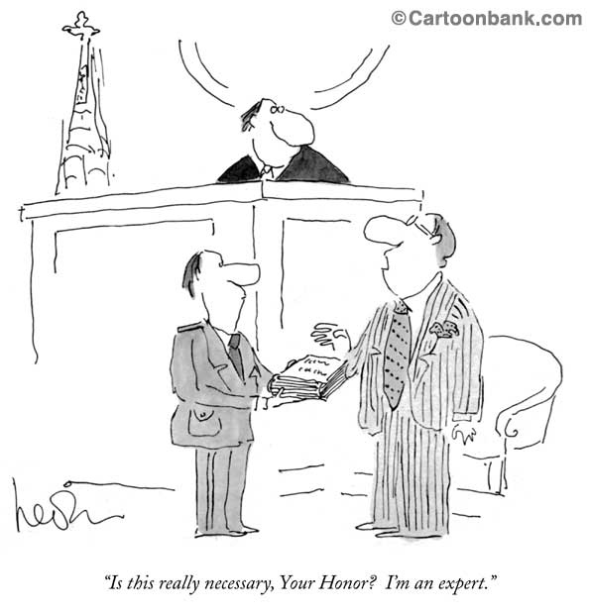
When you cross-examine an expert, there are four main areas where you can have a fight:
- The expert doesn’t have the QUALIFICATIONS: The test for qualifications is low; are they qualified to give an opinion?
- The expert is BIASED: Do they have any of the four traits of expert advocacy?
- The expert DOESN’T HAVE ALL THE FACTS: Sometimes they haven’t cherry-picked; they just don’t know what the case is about
- Lastly, you can POLARIZE THE CASE: Push the Expert’s opinion to the extreme
The expert doesn’t have the QUALIFICATIONS: The test for qualifications is low; are they qualified to give an opinion?
- If there’s a physician, they’re going to have the qualifications.
- The question is whether they have qualifications as good as your expert: Whom should the court prefer?
- In many cases, qualifications will be an important consideration
Qualifications
- In Crawford v. Nazif, the defendant’s standard of care expert was Dr. Pawliuk, a psychiatrist.
- Dr. P looked older, authoritative. But no leadership positions. And when you look at his CV closely, he was a mature student when he went to med school. So not as many years of experience as one might think.
- Gillespie on the other hand had been practising since the 1970s, was a president of BCMA, Doctors of BC. I put it to Dr. P that he has only ever been a member of BCMA. Not really relevant to their specific expertise, b/c BCMA is like the CBA for us, but bolsters my own expert’s qualifications while degrading the opposing expert’s.
The expert is BIASED: Is there expert advocacy?
- Does the expert always only represent one side? Are they a cherry-picking expert?
  - In Wallman v. John Doe, 2014 BCSC 79 Dr. Derryck Smith was criticized for ‘cherry picking’ evidence in support of his opinion:
449 Dr. Smith's view was that the Accident was a minor impact, there was no objective evidence of a concussion and it was therefore "preposterous" to suggest that the plaintiff sustained a concussive injury. However, Dr. Smith did not attribute the plaintiff's subjectively reported symptoms to any other cause. He ignored and made no attempt to reconcile the contrary opinions of other respected physicians and the diagnostic criteria for concussions set out in authoritative text books he had previously endorsed because they "set the bar way too low". He relied only upon information that was supportive of his opinions and disregarded the information that was not. He sought to justify his approach by stating: "These are the facts and assumptions that I relied upon in forming my opinion. Obviously I did not rely upon [the other information I was given] because it's not reflected in my facts and assumptions". This kind of "cherry-picking" by experts is unhelpful. Dr. Smith was not an objective expert witness. I do not accept his opinion that the plaintiff did not suffer a concussion in the Accident.
- Do they only hold onto the facts of the side that retained them or do they consider all the facts?
- Do they have a financial interest in the outcome?
- Have they have had previous negative judicial commentary? (Already discussed looking at the expert’s history before the courts in Dealing With Your Own Expert)
- All of this goes to bias and the four traits of expert advocacy
4 TRAITS OF EXPERT ADVOCACY:
- Definition of advocacy: the act of arguing on behalf of a particular issue, idea or person
- The case law considering expert evidence confirms four factors for determining whether an expert has adopted the role of an advocate:
  - Selective experts
  - Expert commenting on credibility
  - Experts and pecuniary interest in litigation
  - Expert’s demeanor in court
- Dr. Schweigel acted as an advocate for the defendants, not an expert whose sole purpose is to assist the Court. He highlighted all matters that would support the defence position and either downplayed or ignored those that would support the position of Mr. Barnes. Barnes v. Richardson, 2008 BCSC 1349
- Throughout the cross-examination of Dr. Davis, he was argumentative and refused to consider material facts which might detract from his opinion. This is not the proper role of an expert, who must provide an unbiased opinion and consider material facts which are put to him or her.
Grewal v. Brar, 2004 BCSC 1157, citing
Perricone v. Baldassarra, [1994] OJ No. 2199 (Ont Gen Div)
- First, has the expert considered all of the evidence, both positive and negative, and incorporated this evidence into the expert opinion?
- Courts are vigilant in screening experts that deliberately highlight particular aspects of the evidence that support their opinion and exclude or ignore relevant evidence that detracts from their opinion.
- Expert witnesses owe a duty to the court to remain unbiased in their opinions. This duty requires that experts consider all evidence that is provided to them. Selective sampling of the evidence in order to promote the retaining party’s theory of the case will be seen as advocacy and the deemed inadmissible.
- It is a fundamental axiom of our trial process that the ultimate conclusion as to the credibility or truthfulness of a particular witness is for the trier of fact, and is not the proper subject of expert opinion… A judge or jury who simply accepts an expert's opinion on the credibility of a witness would be abandoning its duty to itself determine the credibility of the witness.
R. v. Marquard, [1993] SCR 223 (SCC), citing R. v. Béland, [1987] 2 SCR 398 (SCC)
- The Supreme Court of Canada indicated that a witness's credibility is a proper question for the trier of fact and not for experts.
- The rationale is that issues of credibility do not require the specialized expertise of an expert.
- Where an expert comments on credibility, the opinion will almost universally be interpreted as advocacy and deemed inadmissible.
- Many physicians feel the need to comment on credibility – observed the plaintiff sitting for X minutes, exaggerative behavior, etc.
- “Credibility is within the proper function of a jury … I expect expert witnesses to remain within the boundaries of their expertise and not to artfully craft letters calculated to advance their clients' interests, by suggesting the plaintiff is financially motivated.”
Giang v. Clayton, 2003 BCSC 1236
- Experts may rely on the results of psychological testing when expressing opinions about the validity of the complaints and the extent of injuries. However, here the "diagnosis" of malingering is a comment by the doctor [Wiseman] as to the plaintiff's credibility or reliability as a witness. As such, it is inadmissible opinion evidence.
Brough v. Richmond, 2003 BCSC 512
- [Dr. Hayes’] final opinion or conclusion is simply a statement that there are secondary factors to the plaintiff’s complaints of disability. That is neither a fact nor a conclusion that requires expert evidence.”
Kuhne v. Minifie, 2000 BCSC 1778
- Another area of potential conflict for experts is the issue of pecuniary interest in the outcome of the litigation.

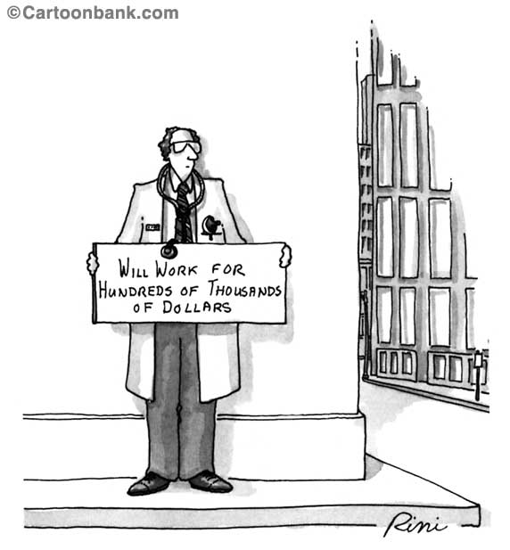
- The courts are increasingly skeptical of expert witnesses with strong financial ties to one party, which while not fatal to the evidence, does often raise an apprehension of bias.
- The concern is that experts are inclined to provide a favourable analysis for the party that pays their fee, particularly, if they wish to be hired again.
- ICBC publishes how much it pays its “suppliers” every year. Despite Mr. Justice Abrioux’s decision, it continues to hire orthopaedic surgeons and pay them a lot of money annually. The following amounts are from the 2017/2018 fiscal year:
  - Dr. Olli Sovio, ortho $314,181 – he’s semi-retired but in previous years he’s billed much more.
  - Dr. Marc Boyle, ortho $528,225
  - Dr. Simon Horlick, ortho $819,991
  - Dr. Kevin Solomons, psychiatrist $877,065 – some years he’s billed over $1m to ICBC
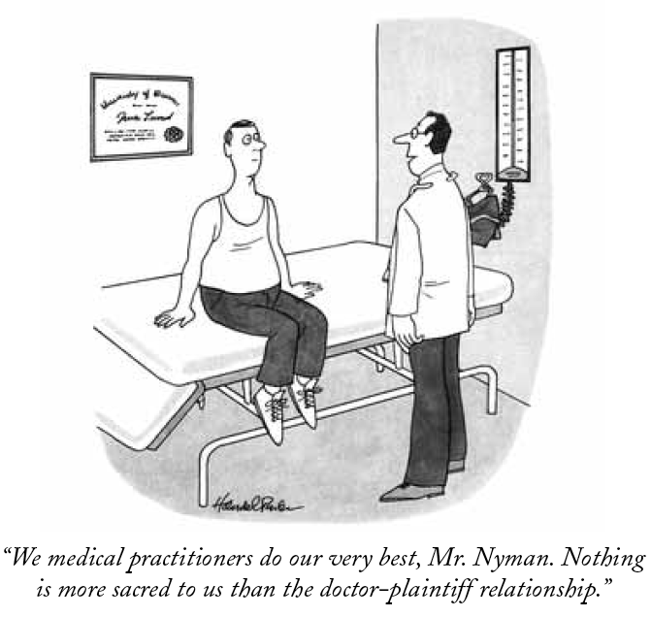
- Treating physicians: “Where the care giver is an expert witness permitted to express opinions there is room for concern over his or her disinterest in the outcome of the litigation. I am not referring to bias or even apprehension of bias. I am referring to…the fact that honest people naturally intensify a little in the direction in which their interests point. This is a matter, then, that affects the weight to be given the evidence of this witness.”
Lee v. Swan, [1996] BCJ No. 259 [BCCA]
- In my view, the suggestion that evidence has been tainted because of motives of economic reward applies not to the plaintiff, but rather, to the defendant's expert, Dr. Fenton. Dr. Fenton has been receiving a substantial amount of referral work from ICBC for many years…These monies were received as payment for the preparation of what Dr. Fenton classifies as independent medical reports, which he says he prepares for the Court. Chiacig v. Chiacig, 2001 BCSC 1709
Selective Experts and DRAFT REPORTS(!)
Rule 11-6 — Expert Reports: Production of documents
(8)Unless the court otherwise orders, if a report of a party's own expert appointed under Rule 11-3 (9) or 11-4 is served under this rule, the party who served the report must,
(a)promptly after being asked to do so by a party of record, serve on the requesting party whichever one or more of the following has been requested:
(i)any written statement or statements of facts on which the expert's opinion is based;
(ii)a record of any independent observations made by the expert in relation to the report;
(iii)any data compiled by the expert in relation to the report;
(iv)the results of any test conducted by or for the expert, or of any inspection conducted by the expert, if the expert has relied on that test or inspection in forming his or her opinion, and
(b)if asked to do so by a party of record, make available to the requesting party for review and copying the contents of the expert's file relating to the preparation of the opinion set out in the expert's report,
(i)if the request is made within 14 days before the scheduled trial date, promptly after receipt of that request, or
(ii)in any other case, at least 14 days before the scheduled trial date.
See T.S. v. Gough, 2022 BCSC 264

Did the accident cause or contribute to the alcohol use disorder?
[194] The addiction experts agree that the cause of an alcohol use disorder is multifactorial. Dr. Sobey identifies several factors that he opines were causative in T.S. developing the alcohol use disorder. Those factors include the psychological distress T.S. experienced as a result of his stepmother’s death and the breakup with M.T. in the days following the accident.
[195] Dr. Sobey did not place the same emphasis on the accident. He opines that the physical and psychological injuries T.S. sustained were “at most a minor causative factor”. He does not explain, or even attempt to explain, why the psychological distress of his stepmother’s death and a breakup he initiated had a causative effect, but the accident, which occurred within days of those events, did not.
[196] In my view, that distinction defies logic. The accident was a major event, resulting in a serious injury that required major surgery. The physical and psychological symptoms affected his ability to function and deprived him of his capacity to work and support himself financially. Without any explanation of why that would only have minor impact on the development of the alcohol use disorder, I do not accept that conclusion.
[197] Even standing alone, Dr. Sobey’s conclusion that T.S.’s break-up with M.T. had a causative effect is illogical. M.T. and T.S. reunited in early August 2017, yet T.S.’s drinking problem continued. If the breakup had caused the alcohol use disorder, it stands to reason that the reunion should have reversed, or at least minimized, that effect. It did not. Again, it is difficult, if not impossible, to discern the basis on which Dr. Sobey has concluded that the break-up had a more significant impact on the development of T.S.’s alcohol dependency than the accident.
[198] In my view, Dr. Sobey’s unexplained and illogical minimization of the accident as no more than a “minor” cause of the alcohol use disorder undermines the credibility of his report.
[199] It is also significant that in an earlier draft of Dr. Sobey’s report, he does not minimize the contribution of the accident to the same degree, opining that the other stressors played “as great or greater role” (emphasis added). That is not to suggest that a change of opinion will, in every case, undermine the credibility or impartiality of an expert. However, there must be some explanation for the change. There is no such explanation here. In my view, the unexplained change further undermines the credibility of Dr. Sobey’s opinion.
[200] I discount Dr. Sobey’s opinion with respect to causation.
[201] The third party argues that Dr. Melamed’s opinion was also flawed in that it was based, in part, on the inaccurate history provided by T.S. However, Dr. Melamed did not solely rely on T.S.’s self-report in reaching her opinion. She also considered other factors including his level of function, drinking pattern and reason for drinking. Based on those factors, she was of the view that his pre-accident alcohol abuse did not amount to a dependence. As set out above, I accept that view.
[202] It is impossible to know whether T.S. would have developed the alcohol use disorder in the absence of the accident. However, to prove causation, a plaintiff does not need to prove to a scientific certainty that they would not have developed the condition but for the accident. They only have to prove that it is more likely than not that the condition was caused by the accident: Fabretti v. Gill, 2014 BCSC 899 at para. 77.
[203] I find that the accident was a significant cause of T.S.’s development of an alcohol use disorder.
The EXPERT’S DEMEANOR IN COURT
- Experts are expected to be:
  - Professional - Non-partisan,
  - Prepared - Review the file and relevant literature, and
  - Personable - avoid aggressive interaction
  - In Chiacig v. Chiacig, 2001 BCSC 1709 the expert was hostile and combative in cross examination and this behaviour detracted from the expert’s opinion: “I find that Dr. Fenton was argumentative and condescending. His interaction with plaintiff's counsel was akin to sparring, indicating that he was more of an advocate than an independent professional. I give his evidence very little weight.”
- In Shearsmith v. Houdek, 2008 BCSC 997, the expert was ill prepared for court which led to an inference that he was an ICBC hack: “Under cross-examination, it was obvious to me that he had not spent as much time, nor was he as objective, in his assessment of the plaintiff as either Dr. Shuckett or Dr. McKenzie. Dr. Piper impressed upon me that he was more of an advocate for ICBC than an objective expert, and I therefore attach little weight to his evidence.”
The expert DOESN’T HAVE ALL THE FACTS:
Sometimes they haven’t cherry-picked; they just don’t know what the case is about
For example, the expert doesn’t have all the facts and is saying that your client is in a state of decline. If you can then show your client is not in a state of decline… Ask:
- If he’s declining, how’s he doing at work?
- At home?
- In his social life?
- Is he working full-time or part-time?
- Is he missing work or showing signs of absenteeism?
You are the master of your client’s facts so you’re on much stronger ground when you can cross an expert on the facts of the case as opposed to going toe to toe with an expert on the science– then you’re on much weaker ground
Lastly, you can POLARIZE THE CASE:
Push the Defence’s opinion to the extreme
- E.g.: When you said they were on a downward decline prior to the accident, was it when they were working 60hrs/week before the accident, never having missed a day for 3 years, taking their child to soccer practice when their spouse was sick?
  - Our job is to reveal holes on the other side’s case – you want to make sure you know all these facts
  - E.g. degenerative spine – pre-existing but made symptomatic by an accident
- Push the expert’s opinion to the extreme
- Expert says your client was in a state of decline prior to the accident without having all the facts…
  - “Was this downward decline happening when they were working 60 hours/week?”
  - “Not having missed a day for 3 years?”
  - “While taking care of their child when their spouse was sick?”
Our job: Reveal holes in the other side’s case – Make sure you know all the facts!
- Expert says your client has non-organic findings…
  - “You’re not saying they’re lying or exaggerating, are you?”
  - “No, you’re saying their response to light physical stimulus is not consistent with the damage to the tissues.”
  - “So you’re saying there’s a psychological component??
  - Saying there’s a psychological component ≠ Saying someone is lying
  - Expert says there’s a long list of reasons why your client might have that response – they might be malingering…
  - “Lying or exaggerating when they went to the hospital when they had a head injury?”
  - “How about when their doctor sent them to physio and they went every time?”
  - “Malingering when they started taking antidepressants because they couldn’t function anymore?”
  - “At what point did you opine that they were lying or exaggerating or malingering?”

Appendix A: Cross-examination of Dr. Sobey in T.S. v. Gough
[To be provided in redacted form]

Appendix B: Closing Argument in T.S. v. Gough re: Dr. Sobey

Dr. Paul Sobey
- Dr. Sobey is a family physician with a fellowship in addiction medicine. He is not a psychiatrist.
- Dr. Sobey purported to assign weight to the various facts and he ‘cherry-picked’ the facts that were most helpful to the third party’s theory on causation. It was not Dr. Sobey’s role to select the facts and offer a conclusion – that is the domain of the trier of fact. His effort do so was thinly veiled advocacy.
- In Wallman v. John Doe, 2014 BCSC 79 [Tab 33], ironically, it was Dr. Derryck Smith who was criticized for ‘cherry picking’ evidence in support of his opinion:
449 Dr. Smith's view was that the Accident was a minor impact, there was no objective evidence of a concussion and it was therefore "preposterous" to suggest that the plaintiff sustained a concussive injury. However, Dr. Smith did not attribute the plaintiff's subjectively reported symptoms to any other cause. He ignored and made no attempt to reconcile the contrary opinions of other respected physicians and the diagnostic criteria for concussions set out in authoritative text books he had previously endorsed because they "set the bar way too low". He relied only upon information that was supportive of his opinions and disregarded the information that was not. He sought to justify his approach by stating: "These are the facts and assumptions that I relied upon in forming my opinion. Obviously I did not rely upon [the other information I was given] because it's not reflected in my facts and assumptions". This kind of "cherry-picking" by experts is unhelpful. Dr. Smith was not an objective expert witness. I do not accept his opinion that the plaintiff did not suffer a concussion in the Accident.
- Dr. Sobey’s conclusion on causation was biased and, quite simply, nonsensical. It defies common sense to suggest that a Collision of this kind and injuries of the magnitude T.S. suffered played only a minor role in onset of his severe alcohol use disorder. T.S. suffered a serious orthopedic injury requiring major surgery. He was unable to return to his previous job. Dr. Sobey, nonetheless, tries to suggest that the worsening of T.S.’s alcohol use following the Collision was coincidental timing, and was more triggered by two other non-tortious events: the death of his stepmother, Marilyn, and his break-up with his fiancée, Me.T. The latter purported cause is especially nonsensical because Me.T. and T.S. reunited in early August 2017, yet T.S.’s problem drinking continued and his consequential losses accumulated over the ensuing year, while Me.T. and T.S. were together.
- Most importantly, it is obvious from the whole of the evidence that T.S. was and is suffering from PTSD arising from the Collision, and there is a well-recognized correlation between PTSD and alcohol use disorder. Dr. Sobey completely discounted the possibility that T.S. might suffer from PTSD. Notably, his application of the PTSD screening tool, the PSL-5, achieved values that were wholly in conflict with the values obtained by Drs. Ganesan and Smith, both of whom are psychiatrists. Dr. Sobey (reluctantly) deferred to Dr. Smith on the diagnosis of PTSD.
- Two visual aids were put to Dr. Sobey in cross-examination, drawn from a policy paper he co-authored in 2009, Stepping Forward. This policy paper was commissioned by the Doctors of BC in an effort to improve addiction care in British Columbia.
- One of those helpful visual aids was at page 11 of that policy paper:
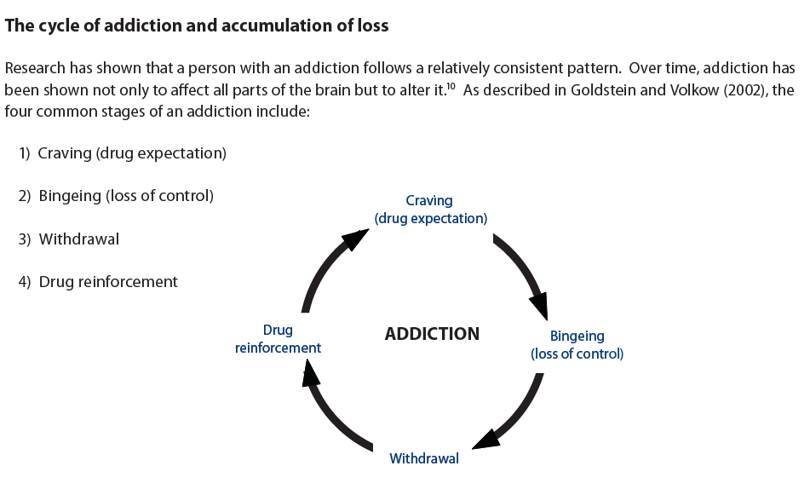
- Inexplicably, Dr. Sobey attempted to suggest under cross-examination that this published description of the well-recognized cycle of addiction – including the presence of withdrawal – was not critical to his diagnosis of alcohol use disorder in T.S. before the Collision. He maintained it was possible for T.S. to have an alcohol use disorder without withdrawal symptoms, relying on the new DSM-5 checklist and scoring of equalized criteria; he did so in an effort to defend his theory that the plaintiff suffered from a pre-Collision alcohol use disorder despite the fact he was still going to work during the week, without any observed absences or concerns about productivity.
- A flow chart from page 12 of Stepping Forward further demonstrated the frailties of Dr. Sobey’s opinion on causation. The “Accumulation of Losses” flow chart reads like a checklist for addiction. T.S. checked none of the boxes before the Collision; he checked all of the boxes after the Collision.
- Indeed, on the very day of the Collision:
  - T.S. was still together with his fiancée and they were saving to buy a home together;
  - T.S. had been out exercising and socializing with friends without using any alcohol (he was not isolating);
  - T.S. was stably employed and he had finished working a full shift, starting at 6:00 a.m.; and
  - T.S. had no criminal record whatsoever, despite Dr. Sobey’s mistaken assumption that T.S.’s DUI pre-dated the Collision.
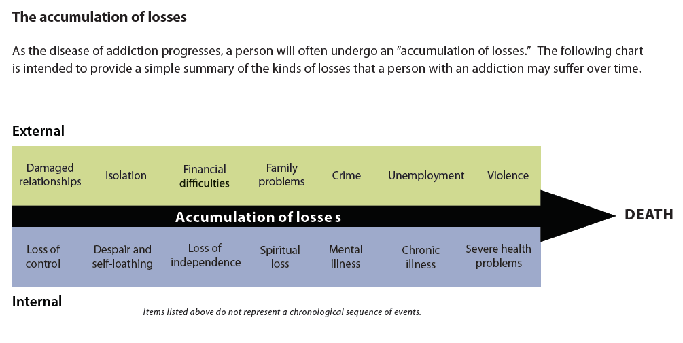
- Following the Collision, T.S. rapidly progressed along this flow chart. Externally:
  - His relationship with Me.T worsened to the point that she left him. She found love elsewhere and she admitted in cross-examination she had ‘had enough’.
  - He isolated and did not pursue social relationships.
  - He had financial difficulties and was borrowing money to get by.
  - He had problems with both the T. family and his sister T.D. because of his drinking. He was eventually kicked out of both family homes.
  - He was thrown into the drunk tank and he drove drunk, resulting in a driving prohibition.
  - He was unemployed and could not find suitable alternative work (Charlotte Ballisager could not help him return to work in any capacity because of the barrier of untreated alcohol use disorder).
  - He was violent with Ma.T. on two occasions while he was ‘blackout drunk’ – he had never been violent with Ma.T. prior to the Collision. T.S. was also threatening violence to himself: he was suicidal by the summer of 2018.
- Internally, T.S. checks all the boxes following the Collision, too:
  - He had completely lost control of his ability to manage the quantity of his alcohol.
  - He felt despair and self-loathing to the point of wanting to cause himself harm.
  - He could not support himself and he was homeless without the assistance of the T. family or his sister, T.D.
  - He had no sense of purpose.
  - He was depressed and he also suffered from PTSD.
  - He was chronically ill by June 2018, experiencing multiple hospital admissions and eventually residential addiction treatment and a prolonged course of second stage treatment.
  - He was experiencing severe health problems because of his drinking, including obesity with aggravation of his chronic pain and PTSD.
- Another concern with Dr. Sobey’s opinion is the apparent discrepancy between his history taking and opinion in his file materials and what shows up in his final report.
- Dr. Sobey’s factual assumption (ee) at page 12 of his report states, “[T.S.] drank due to grieving the loss of his mother, the loss of his fiancée, and pain and psychological distress from the subject accident.” He never explains just what T.S.’s self-report of ‘pain and psychological distress’ involved.
- A detailed note buried at page 14 in Dr. Sobey’s handwritten real-time notes from his interview of T.S. never made it into his final draft – T.S. self-reported to Dr. Sobey that after the Collision, he drank to numb flashbacks and the memories of the collision and seeing his friend in the backseat who he thought was dead.
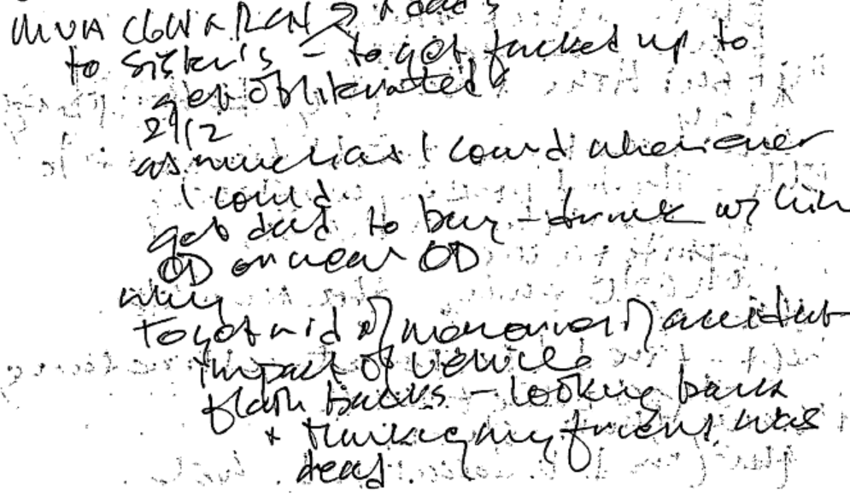
- A draft of Dr. Sobey’s report was also in his working file. In that draft, he did not so strongly minimize the contribution of the Collision to T.S.’s development of a severe alcohol use disorder, saying that T.S.’s other stressors played “as great or greater role” [emphasis added]. His opinion changed in his final draft of the report, wherein he argues more forcefully the Collision was “at most a minor causative factor and more temporally related to his developing a severe alcohol use disorder and consequences thereof.”
- It is not Dr. Sobey’s role to assign weight to the facts: this is the domain of the trial judge.
- Dr. Sobey failed to abide by his duty to give impartial evidence to assist the court. Cross-examination readily revealed that he was an advocate, through and through.
- Where Dr. Sobey’s opinion conflicts with other evidence, his opinion should be given no weight whatsoever.

