Law 433C.001 | Personal Injury Advocacy | 2026 Term 2
Professors:  SANDRA KOVACS  TANYA MARTIN | Tel: (604) 681-9344  Email: sk@kazlaw.ca  Email: tmartin@kazlaw.ca  Office: 1900-570 Granville Street, Vancouver BC | Mondays 5:00 – 8:00 pm  UBC Faculty of Law  Room 121

WEEK 8: Monday, March 2, 2026
- TEACHING OBJECTIVES & OVERVIEW
The goal of this week’s class is to learn how (and be inspired) to handle a sexual assault claim from opening to closing, inclusive of trial.
Recommended Readings / Audio / News Articles:
- Anderson v. Molon, 2020 BCSC 1247
- O’Neill v The Seminary of Christ the King, 2020 BCSC 2209 (CanLII)
- D.H. v The Seminary of Christ the King, 2022 BCSC 2444 (CanLII)
- Doe v The Roman Catholic Archbishop of Vancouver, 2023 BCSC 833 (CanLII)

- Proctor, J., CBC News, February 5, 2024, 'See no evil, hear no evil, speak no evil' culture of Catholic Church challenged at sex abuse trial, https://www.cbc.ca/news/canada/british-columbia/catholic-sex-trial-kilty-clavin-1.7105492
- John Doe v The Roman Catholic Archbishop of Vancouver, 2024 BCSC 2665 (CanLII)
- S.A.S. #1 v Quigley, 2025 BCSC 2301 (CanLII)
- S.L.K. v A.B., 2025 BCSC 2617 (CanLII) (under appeal)
- MEET OPPOSING COUNSEL
We are pleased to have Janis McAfee of Dolden Wallace Follick LLP join us!
https://dolden.com/lawyer/janis-mcafee/
https://www.bestlawyers.com/lawyers/janis-mcafee/396236
- INTAKE
- Be trauma-informed: The Trauma-Informed Lawyer (simplecast.com)
- The intake process usually involves at least two meetings; in some cases, many more, and in some instances, complainants communicate with me over years without actually ever retaining me. Many say that picking up the phone or coming to see me for the first time was terrifying and took many attempts. Some clients who reach out are disclosing their trauma to another human being for the very first time.

- Some clients with posttraumatic stress disorder experience fits of rage and anger; they become hyper-aroused when telling me their story. Sometimes clients dissociate in front of me – you can see in their eyes and facial expressions that they are not present. I have witnessed a client’s panic attack, with the immediate onset of laboured breathing. I have several clients who suffer dissociative seizures, one severely; her head or her arms will convulse involuntarily, resembling an epileptic seizure, but the root cause of these convulsions is not abnormal electric activity in the brain but rather an unconscious neurological-type response to painful psychological triggers. She has no control over these dissociative seizures, just the same as an epileptic patient has no control over seizures: these episodes are not ‘put on’.

- It is important to remember that someone suffering from mental illness involuntarily experiences physically distressing symptoms as a result of the body’s stress response to the psychological trigger. Patience, compassion, and being trauma-informed is absolutely critical when working with these clients.

- Many survivor plaintiffs are not primarily interested in money but truth, validation, and accountability. They want to achieve some sense of justice and closure about what happened to them. Sexual violence is defined by power; survivors are vulnerable and usually have low self-esteem and lack confidence. I explain that the process can help them to reclaim their power and possibly offer them some peace, as much as that may be possible; although not guaranteed, that is my goal for them.
- Empower the new client to make choices to move forward at their own pace, in a fully-informed way.
- Referrals to resources: the importance of counselling and/or peer support, sometimes residential treatment.
- TRAUMA-INFORMED DEFENCE LAWYERING (Janis McAfee)
Slide show: Trauma-Informed Defence Lawyering
- NO LIMITATION PERIOD
Survivors often take many years to come forward with their claims. There are various reasons for this:
- PTSD – Avoidance is a hallmark symptom of the diagnosis, and sufferers will avoid reminders of the abuse, including litigation
- Shame – many survivors feel shame and blame themselves for the abuse they suffered. This is sadly not uncommon.
- Some worry about hurting family members or their community. This is especially relevant where the abuse was perpetrated by a trusted family member or religious elder.
- Sexual violence is all about POWER – and many victims feel weak or disempowered to take action, and many fear their abuser, distrust authority and the administration of justice generally, and/or they fear the consequences of pursuing justice, including secondary victimization. Many survivors describe their experience in court as ‘the second rape’.
For this reason, the artificial limitation period of two years, applicable for public policy reasons for most tort claims, does NOT apply to tort claims relating to sexual misconduct, assault, or abuse.
Limitation Act (gov.bc.ca)

Exempted claims
3 (1)This Act does not apply to the following:
(i) a claim relating to misconduct of a sexual nature, including, without limitation, sexual assault,
(i) if the misconduct occurred while the claimant was a minor, and
(ii) whether or not the claimant's right to bring the court proceeding was at any time governed by a limitation period;
(j) a claim relating to sexual assault, whether or not the claimant's right to bring the court proceeding was at any time governed by a limitation period;
(k) a claim relating to assault or battery, whether or not the claimant's right to bring the court proceeding was at any time governed by a limitation period, if the assault or battery occurred while the claimant
(i) was a minor, or
(ii) was living in an intimate and personal relationship with, or was in a relationship of financial, emotional, physical or other dependency with, a person who performed, contributed to, consented to or acquiesced in the assault or battery;
- WHO TO SUE
The unfortunate reality is that litigation is expensive, and there is no point in bringing action to pursue a dry judgment against a defendant perpetrator of abuse who is insolvent. This creates a serious access to justice issue for survivors, since the criminal forum is often challenging for a sexual assault complainant, too (see the Globe and Mail’s 2017 series, Unfounded: Police dismiss 1 in 5 sexual assault claims as baseless, Globe investigation reveals - The Globe and Mail)
Often, if the perpetrator does not have assets, plaintiff’s counsel must be alive to the possibility of suing a secondary defendant who may have insurance coverage or assets to satisfy a judgment.
Some institutions, such as School Boards, Youth Service Organizations (YSOs), Churches, et cetera, can be held to be vicariously liable for the intentional torts of their employees or agents.
The Roman Catholic Church legally operates in Canada through diocesan corporations, each under the direction of a Bishop. Each Bishop is appointed by and directly accountable to the Pope via the Papal Nuncio (the equivalent of the Pope’s ambassador to Canada), whose jurisdiction arises from the Holy See and is administered by the Roman Curia. Each diocese is an incorporated entity, usually via special statute of the Canadian province in which it operates. For example:
- The Kamloops Diocese is a corporation sole of perpetual succession pursuant to the Bishop of Kamloops, the Roman Catholic (Incorporation) Act, SBC 1947, c. 102;
- The Nelson Diocese is a corporation sole of perpetual succession pursuant to the Bishop of Nelson, The Roman Catholic (Incorporation) Act, S.B.C. 1937, c. 81;
- The Victoria Diocese is a corporation solé incorporated pursuant to the Bishop of Vancouver Island, The Roman Catholic (Incorporation) Act, S.B.C. 1892, c. 56, as amended by S.B.C. 1932, c. 65;
- The Vancouver Archdiocese is a corporation sole of perpetual succession pursuant to The Bishop of New Westminster, Roman Catholic (Incorporation), S.B.C. 1892, c. 56, as amended by The Roman Catholic Archbishop of Vancouver Incorporation Act, S.B.C. 1909, c. 62; and
- The Prince George Diocese was the Roman Catholic Episcopal Corporation of Prince Rupert (the Bishop’s seat was moved in 1968), a corporation sole of perpetual succession pursuant to An Act to incorporate The Roman Catholic Episcopal Corporation of Prince Rupert, S.C.1924, Bill 14.
Where the circumstances do not merit the imposition of strict vicarious liability, there may still be a viable claim against a secondary defendant in direct negligence. Or, the claim in direct negligence – or wilful blindness – may be relevant to your plea for punitive damages.
Was there someone else who owed a duty of care to the plaintiff, who knew or ought to have known of the risk of harm to the plaintiff, and who failed to take steps to protect the plaintiff and/or prevent the abuse?
- Bishop Exner, in Anderson v. Molon 2020 BCSC 1247, supra:
[186] The plaintiff’s claim against the Diocese, like any claim in negligence, requires proof of the following elements:
a) the existence of a duty of care;
b) a breach of the standard of care; and
c) that the breach caused damage to the plaintiff.
[187] In this case, I am satisfied that all of these elements were present.
[188] It well established that a diocese owes its parishioners a duty of care to prevent their abuse at the hands of its priests: K. (W.) v. Pornbacher (1997), 1997 CanLII 12565 (BC SC), 32 B.C.L.R. (3d) 360 (S.C.). Although these cases typically deal with the abuse of children, I see no reason why that duty should not also encompass vulnerable, adult parishioners. In any case, at the time Bishop Exner became aware of rumours of Fr. Molon’s sexual improprieties, there was undoubtedly sufficient proximity and foreseeability to found a duty of care. Accordingly, I find the Diocese owed the plaintiff a duty of care to take reasonable steps to prevent her abuse at the hands of Fr. Molon.
[189] The findings of fact I have made in this matter leave no question that Bishop Exner failed to take any such reasonable steps. His conduct fell far short of the applicable standard of care. That said, I do not conclude that the evidence supports a finding Bishop Exner deliberately failed to document the investigation; as was urged by the plaintiff.
[190] Finally, it is clear that but for Bishop Exner’s negligence, Fr. Molon would not have committed the assaults. Had Bishop Exner taken appropriate steps prior to the arrival of the plaintiff, Fr. Molon would never have engaged in the abuse of the plaintiff starting that fall. Whatever damages flow from Fr. Molon’s abuse therefore also flow from the Diocese’s negligence: both were necessary causes of this damage.
…
[252] Nevertheless, I am persuaded that an award of punitive damages against the Diocese is merited in this case on the basis of its direct liability in negligence.
[253] The Diocese failed the plaintiff profoundly in a moment of great need. Bishop Exner was aware of troubling rumours about Fr. Molon as early as the spring of 1976. These rumours were all but confirmed when he confronted Fr. Molon. He knew that Fr. Molon’s conduct put the spiritual and psychological well-being of his parishioners at risk. He chose not to act. As he himself admitted, this resulted in a serious violation of trust.
[254] I have found Bishop Exner was candid about his failings, and expressed regret that he did not act to prevent the plaintiff’s abuse. His conduct was not vindictive or malicious. Nevertheless, his failure to act fell egregiously short of the standard of care required of a person in his position of trust and authority. It was, in my view, a purposeful and reprehensible omission, which merits the condemnation of the court. The compensatory damages already awarded against the Diocese are not sufficient, in my view, to address the blameworthiness of this conduct. I consider an award of $150,000 to be warranted in these circumstances.
Should spouses or bystander parents owe a duty of care and be held liable in negligence for the abuse of children in their care and under their supervision?
Antrobus v. Antrobus, 2015 BCCA 288 (Application for leave to SCC dismissed: 2016 CanLII 13732 (SCC))
- Appeal arising out of a historical sexual assault of a young girl by her grandfather.
- She brought action against her parents alleging they failed to protect her from her grandfather.
- The daughter was successful at trial.
- The BC Court of Appeal allowed the appeal, overturning that trial judgement, finding that the trial judge made palpable and overriding errors of fact. Specifically, the evidence did not support the critical inferences of fact that were underlying the findings of credibility and, by extension, liability.
Legal Analysis
[47] At the outset, it is important to note that William and Joan were not the perpetrators of the abuse. They were bystanders who did not know of the abuse until after it had taken place. Once they learned of the abuse, they immediately barred all further contact between Linda and her grandfather.
[48] In M.M. v. R.F. (1997), 101 B.C.A.C. 97, this Court discussed the factors that must be considered when a claim is brought against a bystander parent. In M.M., the action arose out of a series of sexual assaults inflicted on the plaintiff by the adult son of her foster parent. The claim against the foster mother was dismissed at trial and on appeal. The foundation of the action against the foster mother was, as in this case, negligence and breach of fiduciary duty. The action in negligence turned on the foreseeability of harm.
[49] In analyzing the claim, the majority rejected the submission that the only question which could properly be considered was whether a reasonable person would have understood the risk. The Court concluded that, in determining the foreseeability of harm, the proper question is whether a reasonable person, having the background and capacity for understanding of the particular defendant, would have appreciated the risk (at para. 119). Absent actual knowledge of the wrongdoing, a bystander parent could only be held liable in negligence if he or she was willfully blind as to its existence.
[50] The Court also noted that a defendant must be judged by the standards of the time in which the events took place. In M.M., the events had taken place in the 1970’s but the case had not been brought until 25 years later (at paras. 140-141). The Court found that the foster mother could not be faulted for not having knowledge and attitudes which might be expected at the time of the trial, but were not prevalent at the time that the alleged activity took place. This is a matter of some import in this case ...
- Should homeowner’s insurance policies respond to claims in negligence against spouses of perpetrators?
- The criminal forfeiture principle: An insured who wilfully causes harm cannot seek indemnification under an insurance policy because the loss was not a fortuitous one and likely falls within an exclusion clause in the policy.
- But can an ‘innocent co-insured’ aka a spouse or parent also be excluded from a defence and indemnity under the homeowners’ liability policy?
- Some homeowner’s policies specifically exclude coverage for:
“sexual, physical, psychological or emotional abuse, assault, molestation or harassment, including corporal punishment by, at the direction of, or with the knowledge of any insured; or failure of any insured to take steps to prevent sexual, physical, psychological or emotional abuse, assault, molestation, harassment or corporal punishment;”
- ANONYMITY
- Anonymity is critical for some plaintiffs and, as such, this is an access to justice concern.
- The BC Supreme Court has a practice direction for how to apply for anonymity – filing a claim anonymously is not a right, as the plaintiff MUST seek a court order: https://www.bccourts.ca/supreme_court/practice_and_procedure/practice_directions/civil/PD-61_Applications_to_Commence_Proceedings_Anonymously.pdf
- The Court has always had inherent jurisdiction to order the use of pseudonyms, but historically medical evidence demonstrating the potential for psychological harm was required to justify the use of pseudonyms, see: C.W. v. L.G.M., 2004 BCSC 1499.
- We have advanced the law with regard to the requisite evidentiary foundation for anonymity: see Doe v. A.B., 2021 BCSC 651 (predates Sherman Estate):
    - Judicial notice (i.e. no medical evidence required) can be taken of the objectively discernable harm that befalls plaintiffs in sexual abuse cases if their identity is disclosed.

- We have advanced the law even further by ensuring the plaintiff has control over disclosing her identity and will not be in breach of her own order if she chooses to speak: see A.B. v. Buzza, 2022 BCSC 1969.
- Practice Direction 61 originally required affidavit evidence to be filed in support of the motion. In August 2023, the Chief Justice amended PD 61 to remove this requirement, arguably recognizing the development in the law since Doe v. AB.
- The applicant still needs to meet the test in Sherman Estate v. Donovan. Court openness is presumed and protected by the constitutional guarantee of freedom of expression and is essential to the proper functioning of our democracy versus the potential harm to vulnerable litigants seeking access to justice. See: Sherman Estate v. Donovan, 2021 SCC 25
[37] Court proceedings are presumptively open to the public (MacIntyre, at p. 189; A.B. v. Bragg Communications Inc., 2012 SCC 46, [2012] 2 S.C.R. 567, at para. 11).
[38] The test for discretionary limits on presumptive court openness has been expressed as a two-step inquiry involving the necessity and proportionality of the proposed order (Sierra Club, at para. 53). Upon examination, however, this test rests upon three core prerequisites that a person seeking such a limit must show. Recasting the test around these three prerequisites, without altering its essence, helps to clarify the burden on an applicant seeking an exception to the open court principle. In order to succeed, the person asking a court to exercise discretion in a way that limits the open court presumption must establish that:
(1) court openness poses a serious risk to an important public interest;
(2) the order sought is necessary to prevent this serious risk to the identified interest because reasonably alternative measures will not prevent this risk; and,
(3) as a matter of proportionality, the benefits of the order outweigh its negative effects.
Only where all three of these prerequisites have been met can a discretionary limit on openness — for example, a sealing order, a publication ban, an order excluding the public from a hearing, or a redaction order — properly be ordered. This test applies to all discretionary limits on court openness, subject only to valid legislative enactments (Toronto Star Newspapers Ltd. v. Ontario, 2005 SCC 41, [2005] 2 S.C.R. 188, at paras. 7 and 22).
[39] The discretion is structured and controlled in this way to protect the open court principle, which is understood to be constitutionalized under the right to freedom of expression at s. 2(b) of the Charter (New Brunswick, at para. 23). Sustained by freedom of expression, the open court principle is one of the foundations of a free press given that access to courts is fundamental to newsgathering. This Court has often highlighted the importance of open judicial proceedings to maintaining the independence and impartiality of the courts, public confidence and understanding of their work and ultimately the legitimacy of the process (see, e.g., Vancouver Sun, at paras. 23-26). In New Brunswick, La Forest J. explained the presumption in favour of court openness had become “‘one of the hallmarks of a democratic society’” (citing Re Southam Inc. and The Queen (No.1) (1983), 1983 CanLII 1707 (ON CA), 41 O.R. (2d) 113 (C.A.), at p. 119), that “acts as a guarantee that justice is administered in a non-arbitrary manner, according to the rule of law . . . thereby fostering public confidence in the integrity of the court system and understanding of the administration of justice” (para. 22). The centrality of this principle to the court system underlies the strong presumption — albeit one that is rebuttable — in favour of court openness (para. 40; Mentuck, at para. 39).
An emerging issue is defendant anonymity. In Doe v. A.B., 2021 BCSC 651, the defendant A.B. was granted anonymity, but this decision predated Sherman Estate. Recently, in S.L.K. v A.B., 2025 BCSC 2617 (CanLII), another defendant was granted anonymity.
- IDENTIFYING THE CAUSE OF ACTION
  - The usual plea is in assault and battery
  - Does the continuum of grooming constitute an independent cause of action in trespass to the person? See: McDonald v Conroy and Gorey Community School [2020] IECA 239 (Ireland)
  - The plaintiff alleged she was physically and sexually assaulted and falsely imprisoned by the first defendant, who was a chaplain and religion teacher.
  - The plaintiff was successful at first instance. The High Court held that the first defendant was guilty of the tort of grooming. The second defendants were vicariously liable. The defendants appealed. The Court of Appeal set aside the order of the High Court and directed a rehearing.

The tort of grooming
  - The Court of Appeal referred to the earlier first instance Irish case of Walsh v Byrne [2015] IEHC 414. This had established that a tort of grooming existed. In Walsh the court defined the tort of grooming as:
"a combination of behaviour by which a child is befriended, to gain or her confidence and trust and which includes a process by which a person prepares a child, significant adults and the environment for the abuse."
  - In the present case the first defendant submitted that grooming was not a stand-alone tort and was only actionable if it led to sexual abuse.
  - The Court of Appeal maintained there were significant questions about whether there is a stand-alone tort of grooming. It determined that it would not be appropriate to resolve these issues on appeal, but that they should be considered at the rehearing.
  - When commenting upon the decision in Walsh the Court of Appeal noted that the judge had not referred to any authority – Irish or otherwise – in which grooming was recognised as a civil tort.
  - Is there a breach of privacy claim?
    - Sometimes, the governing institution does not keep the information concerning the complaint of sexual assault private. See Doe v. A.B.
  - A new emerging tort of “sexual harassment”?
    - In Caplan v. Atas, 2021 ONSC 670, the defendant vexatious litigant was sued for defamation, harassment and other claims for her internet communications.
    - The tort of intentional infliction of mental suffering was inadequate in these circumstances because one element of the cause of action is behaviour that “results in visible and provable illness”, and the court did not have evidence of such illness noting “One would hope that a defendant’s harassment could be brought to an end before it brought about such consequences” and that “The law would similarly be deficient if it did not provide an efficient remedy until the consequences of this wrongful conduct caused visible and provable illness.”
    - The facts did not squarely fit with the tort of invasion of privacy and “intrusion upon seclusion” because the defendant has not invaded the plaintiff’s private affairs. She had used photographs made public on the Internet. It was the repeated use of these photographs combined with false statements about the individuals that was the “essence of her wrongful conduct”.
    - Drawing from American case law, the plaintiffs had proposed tort of harassment of internet communications, which the Court held should be recognized in Ontario as “harassment” most aptly described what the defendant had been doing to the plaintiffs. Moreover, the ability to order the defendant to stop harassing the plaintiffs “provided remedial breadth not available in the law of defamation”.
    - The stated test for the tort of harassment in internet communications is as follows:
- Where the defendant maliciously or recklessly engages in communications conduct so outrageous in character, duration, and extreme in degree so as to go beyond all possible bounds of decency and tolerance;
- With the intent to cause fear, anxiety, emotional upset or to impugn the dignity of the plaintiff; and
- The plaintiff suffers such harm.
A new statutory and common law tort of disseminating sensitive / private images?
In Alberta, the Court of Queen’s Bench has already recognized a new, emerging tort for “Non-Consensual Sexual Imaging Sharing”: see ES v Shillington, 2021 ABQB 739 (CanLII)
The new Intimate Images Protection Act was introduced in British Columbia just last Monday, March 6, 2023: https://www.cbc.ca/news/canada/british-columbia/intimate-images-without-consent-legislation-bc-1.6769304
- PLEADINGS
  - Pleadings are important
  - Pleadings can evolve and be amended as you go
  - We further amended the NOCC in Anderson at the end of the trial to include a plea of wilful blindness against Bishop Exner, citing his viva voce evidence at trial in support of that plea. The amendment was allowed, since there was no actual prejudice to the defendants arising from the amendment.
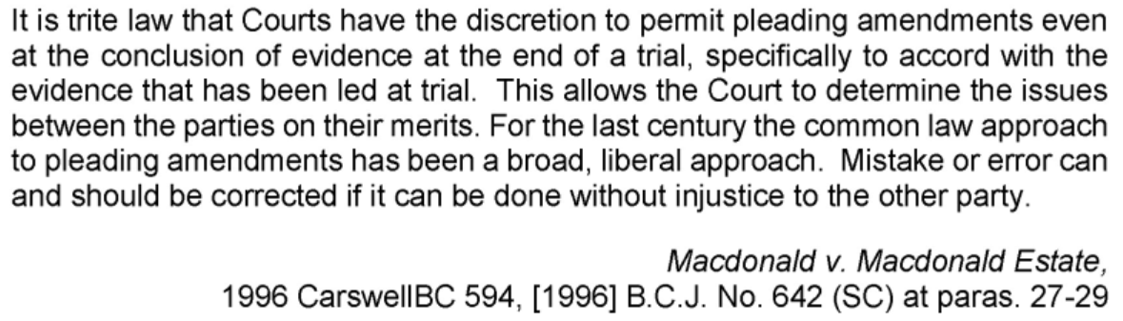
There are some imposed limitations to what you can do in the context of a personal injury action:
Doe v The Roman Catholic Archbishop of Vancouver, 2023 BCSC 833 (CanLII)
- DOCUMENT DISCOVERY
- Often with institutions, document discovery requires considerable work on the part of plaintiff’s counsel to ensure all documents have been produced – particularly when it comes to the Catholic Church, which is known to have engaged in document obfuscation in other jurisdictions. For example, a whistleblower from the Diocese of Buffalo came forward stating critical documents had been hidden in a broom closet: https://www.cbsnews.com/news/whistleblower-says-buffalo-bishop-knew-of-sexual-abuse-allegations-but-did-nothing-60-minutes/
- In DH v. RCAV, the Archdiocese produced a document that from the plaintiff’s perspective was relevant to the allegations of wilful blindness in Doe v. RCAV. We asked the RCAV to produce the document in Doe, but they refused, maintaining it wasn’t relevant. We went to court to seek an order lifting the implied undertaking over the document so we could use it at Doe’s trial. Associate Judge Hughes granted the order (2024 BCSC 272):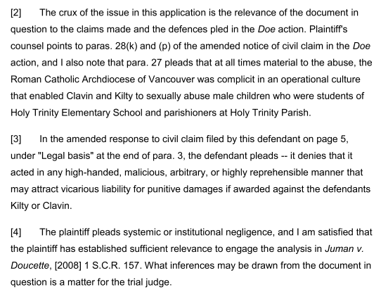
- The key takeaway is that you should not just assume a party’s production is complete. Always request more, and if you have to fight it out in chambers, better to do that than to miss using highly relevant documents at trial.
- EXAMINATION FOR DISCOVERY
- Preparing a survivor plaintiff for discovery
- Book multiple prep sessions – this is an overwhelming process, clients’ PTSD symptoms will be hyperaroused, and splitting it up over the course of several days (or weeks) will make it easier on the client
- If there is a criminal conviction, the plaintiff need not answer questions about the abuse in a civil discovery, as the criminal conviction is presumptively proof in the civil case that what the plaintiff says happened did in fact happen
- Go SLOW, and take as many breaks as the client needs
- Accommodations and aids are important. Some clients get cold extremities – hand warmers can help. Or, Mallory’s dog Tuxedo is a helpful companion for many of our clients: he will sit in their laps and ground them in the present, to help avoid dissociative spells.
(b) Compelling the best witness for discovery on behalf of the defendant
In O’Neill v. The Seminary of Christ the King, 2020 BCSC 2209, we acted for a male complainant who alleged he was abused as a minor in the 1970s by both an Oblate priest and by a College-aged seminarian. In addition to the religious order institutional defendants, we named the Vancouver Archdiocese as defendant, arguing they are vicariously liable for the abuse since they had an opportunity to control the operations at the Seminary, akin to the St. John’s Archdiocese’s relationship with the Christian Brothers of Mount Cashel.
We brought on an application against the Vancouver Archdiocese seeking to compel Exner as the appropriate representative, because a significant paper trail was produced demonstrating that Exner did exercise control over the Seminary’s operations during and after a criminal trial of one of the alleged perpetrators in the 1990s, including authorizing whether the accused could go back to teaching after his acquittal.
The Archdiocese resisted our application, arguing that Exner’s age and health excused him from discovery. Curiously, they relied on medical evidence that predated my cross-examination of Exner in the Anderson trial. They then tried to argue that Exner’s ease of suggestibility under cross-examination demonstrated that he was too ill to testify. Milman J. commented on this in his reasons:
[8] Dr. Viegas has noted that Archbishop Exner was administered a cognitive test by his gerontologist in September 2017, which showed that he had significant memory and executive dysfunction, suggestive of either a mixed or vascular dementia. Dr. Viegas concluded his report as follows:
Even if Arch Adam Exner had possessed the well-being and physical stamina to try and give evidence under cross-examination before and at trial, given his significant cognitive and memory decline, he would be unable to recall dates/details of his conversations/events that have occurred even weeks or months ago, let alone decades ago.
[9] Ms. Kovacs, counsel for Mr. O'Neill, argues that there is nothing in the report suggesting that Archbishop Exner is incompetent to testify. She notes that Archbishop Exner was able to testify not long ago as a witness in another case involving allegations of abuse that occurred within his jurisdiction in the 1970s while he was Archbishop in Kamloops. His testimony in that trial took place over the course of two days in October 2019.
[10] Ms. Kovacs also represented the plaintiff in that case, and it was she who cross-examined him on that occasion. The transcript, or parts of it, has been reproduced in evidence before me. Having reviewed it, I am satisfied that Archbishop Exner was generally able to answer the questions put to him, although it is clear that his memory frequently failed him.
[11] Although the Archbishop argues that he was highly suggestible during that cross-examination, that is not the impression one gets from the transcript. On the contrary, in many cases he stood his ground and resisted suggestions from counsel that he was unable or unwilling to adopt. While he was unable to recall many details, such lapses in memory would not be unexpected from anyone being asked about events that occurred so many decades ago.
Noting that the onus was on the Archdiocese to demonstrate incompetence, Milman, J. allowed my application and ordered Exner to attend discovery on terms I had already proposed (virtual from home with breaks, etc).
That discovery did proceed, but the substantive content of that discovery remains subject to an implied undertaking of confidentiality.
Mr. O’Neill’s case was settled on the eve of trial in September 2022.
- MULTIPLE PLAINTIFFS IN ONE LIABILITY TRIAL
D.H. v The Seminary of Christ the King, 2022 BCSC 2444 (CanLII)
S.A.S. #1 v Quigley, 2025 BCSC 2301 (CanLII)
- SIMILAR FACT EVIDENCE
Harrison v Rayner Estate, 2025 BCSC 2415 (CanLII) (under appeal)
- ADMISSIBILITY OF EXPERT REPORTS
John Doe v The Roman Catholic Archbishop of Vancouver, 2024 BCSC 2665 (CanLII)
- EXPERT EVIDENCE AT TRIAL: HN v. Redgate
Liability
- Dr. Elizabeth Jeglic, psychologist (grooming).
Dr. Jeglic is a renowned expert on childhood sexual grooming from the United States. Her testimony in HN’s case was the first time she had ever testified in Canada.

We introduced her report to buttress our argument on vicarious liability of the school board:

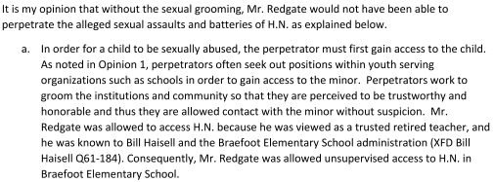
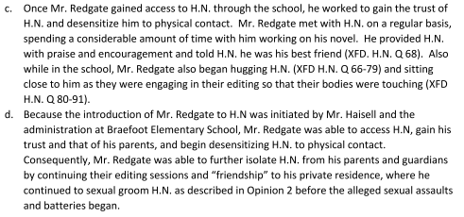
Justice Coval accepted Dr. Jeglic’s opinion in its entirety, but he only relied upon it for one legal question: the limitation period expiry concern. He did not apply her opinion at all to his vicarious liability analysis, which is why the opinion was proffered, and he concluded the school board was not vicariously liable for Redgate’s conduct.
Is this an appealable error? Vicarious liability is a question of mixed fact and law.
Damages
- Dr. Shaohua Lu, psychiatrist

Justice Coval also accepted the evidence of our psychiatrist, Dr. Lu, who opined that HN suffered an indelible and permanent injury that will be with him for the remainder of his life.
[71] Dr. Lu wrote this about the long-lasting effects of childhood sexual abuse:
Childhood abuse, sexual or psychological, can have lasting physical, emotional, and cognitive impacts on the victim. The adverse impacts of childhood abuse can persist for decades, well into adulthood, affecting all aspects of one’s daily life. It has been established in psychiatric literature that childhood abuse is a major risk factor for the development of posttraumatic stress disorder (PTSD), addiction and other serious psychiatric illness. Victims of childhood sexual abuse have higher incidents of mood and anxiety disorders, addiction, personality disorders, general health concerns, and suicide. Childhood abuse is associated with negative education, economic, and social outcomes. Childhood abuse can cause cognitive changes due to the chronic elevated stress and autonomic dysfunction.
… In short, every facet in a person’s life can be adversely and potentially permanently affected by the cumulative negative consequences of childhood sexual abuse. [H.N.] describes these features and experiences.
…
Collectively, [H.N.]’s abuse leaves an indelible mark on his emotional, psychological, moral, cognitive, and personality development. [H.N.] describes a loss of trust and self-confidence for much of his life. He describes a lifelong pattern of indecisiveness, a lack of personal agency, and anger in response to authority. His emotional expression has been affected. He used emotional isolation and avoidance as a way to manage the lingering aftermaths of his years long abuse.
- CROSS-EXAMINATION AT TRIAL
B.C. bishop described former Kamloops priest accused of sex assaults as being a "playboy": lawyer - Kamloops This Week
Former Kamloops bishop Adam Exner testifies at sex assault trial | Vancouver Sun
- The opportunity to cross-examine a Catholic hierarch is not one that comes along very often.
- Of note, there was some challenge in getting Exner to attend at trial. We were originally set for trial for only nine days, and it quickly became apparent that this was insufficient time, for various reasons. Defendants’ counsel warned me he did not plan to call Exner until after a continuation was fixed. That suggestion was not palatable, particularly because Exner is in his 90s. So, we subpoenaed him as an adverse witness in the plaintiff’s case. Crossin, J. encouraged defence counsel to agree with my proposal to stand down the plaintiff’s case to allow him to call Exner as part of the defendant’s case, because if he was called in the plaintiff’s case as an adverse witness, the weight to be given to any of his evidence under cross-examination by defendants’ counsel would be diminished. Defence counsel agreed, and the cross of Archbishop-Emeritus Exner took place over two days in the first phase of trial.
- Exner appeared dressed in a black suit wearing his large pectoral cross on his chest. I spent some time asking him about that cross and his rings, and I walked him through the vestments that he and other priests wear during mass. This was all deliberate in visually setting the scene and highlighting the power differential between clergy and laity.
- I also had a prop: a massive, dusty, old Catholic Encyclopedia our articling student borrowed from the reserves section of the Vancouver Public Library. I spent some time respectfully asking Exner to educate the Court on his background and education, including his doctorate in theology and his two masters degrees in philosophy and theology, which he pursued in Rome, at the Pontifical Gregorian University. I confirmed with him that he was fluent in Latin and that all of his education was taken in Latin. I then had him educate us on some Latin phrases.
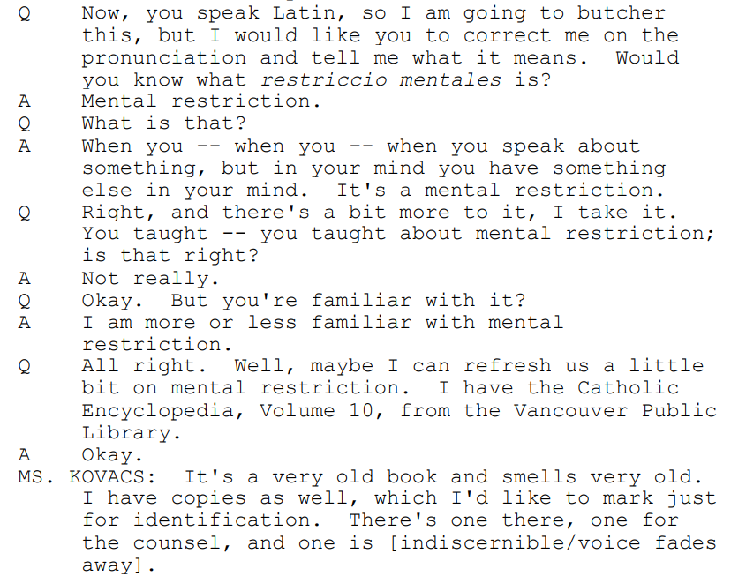
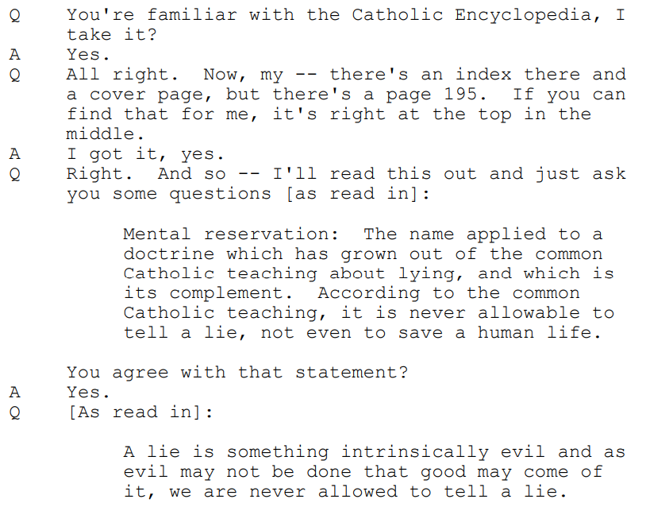
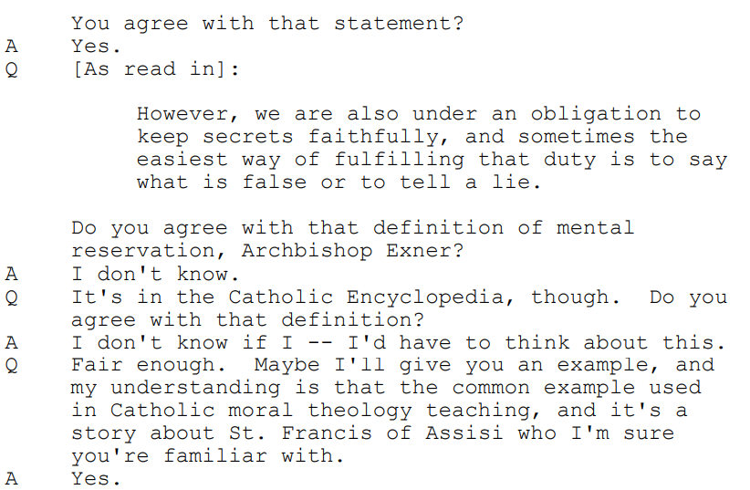
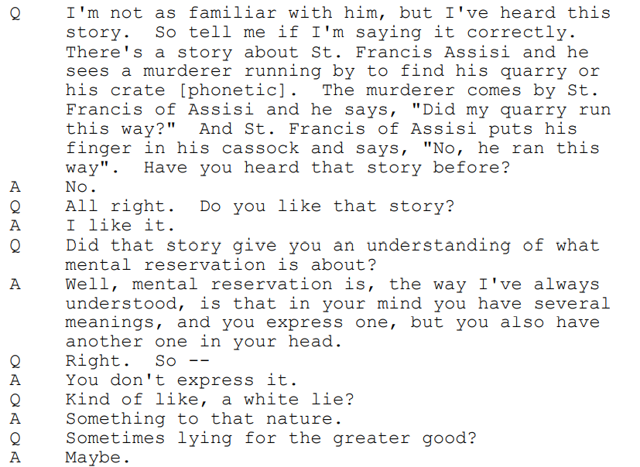
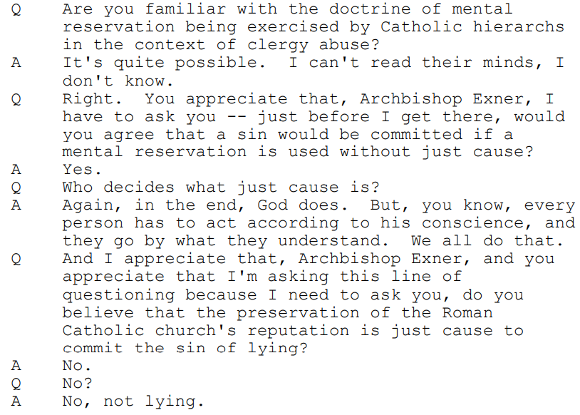
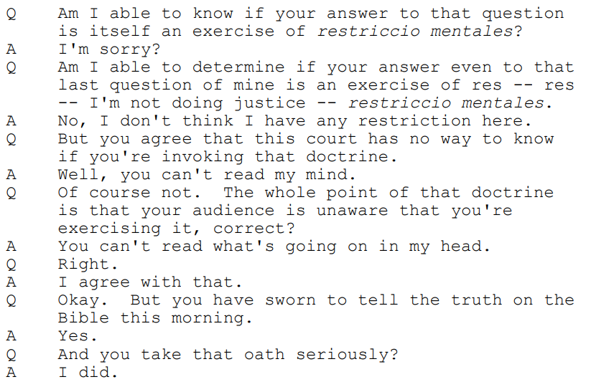
- By that point in the cross, I had already secured the below evidence, in the context of questions about his stature as Archbishop in the Church:
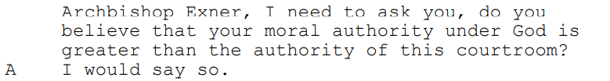
- The point of all of this was to diminish his credibility before the Court, although Crossin, J. declined to find he find he was not credible on the whole, particularly since he did make several admissions against his own interest, although I would respectfully maintain that he was still deliberately holding back some information.
- TRIAL JUDGMENT: H.N. v. School District No. 61, 2024 BCSC 128
The judgment achieved at trial was precedent-setting on quantum. With robust evidence in support of the claim, courts are now prepared to acknowledge the grave consequential harms of child sexual abuse, with corresponding awards of damages.
- Appeal in H.N. v. School District
H.N. v. School District No. 61 (Greater Victoria), 2025 BCCA 144 (CanLII)
Will we get leave to the SCC?
- POST-TRIAL ISSUES
- Post-judgment in Anderson v. Molon, supra, there was predictably a debate over whether the Diocese was jointly and severally liable for the punitive damages awarded for the perpetrator’s conduct.
- The bigger post-judgment issue was about the plea for pre-judgment interest and how that was applicable to the awards for lost earnings and punitive damages – as calculated by our economist, the interest applicable was significant, and had the effect of almost doubling the awards.
- Costs and disbursements are also a significant concern. A successful party is entitled to their costs and disbursements, taxed or as agreed. A Bill of Costs with units for each step in the litigation and a list of disbursements is prepared, and if counsel cannot agree, the Bill can be taxed before the registrar.
- Ultimately, these post-judgment concerns can be resolved as between the parties, but it is important that counsel be live to these concerns in advance of trial or settlement.
- WHY DO THIS WORK?
One of the best gifts ever received from a staff member was a framed, anonymized excerpt of an email from a clergy abuse client that she was carbon-copied on. It said:
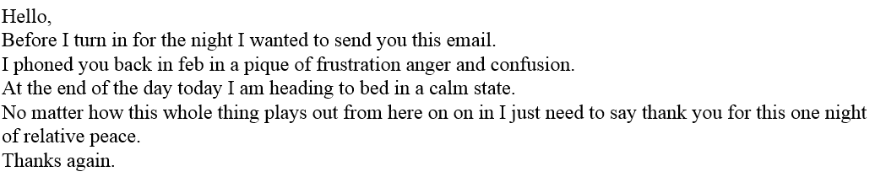
In our recent trial in Doe v. RCAV, after giving a half day of testimony in examination in chief, John Doe came in the following morning and said (paraphrased):
“I have the equivalent of a blackbelt in therapy. I thought there was nothing more that I could do to improve my quality of life. But I went home yesterday, after testifying, and for the first time in 50 years I felt FREEDOM and GRATITUDE. I am grateful to live in a country where I have this process available to me, where I can be heard. Thank you to the Court, thank you to my fellow Canadians, thank you to counsel, and thank you to defence counsel because I recognize you play an important role in this process, too.”
After we settled on Day 7 of trial, John Doe has also said that he gives his experience of the trial a “10 out of 10”.
It is this kind of heartfelt feedback that restores our desire to advocate for survivors. It is difficult work – and a massive responsibility – but the reward is commensurate with that risk and hardship. You have an opportunity to truly make a difference in another human being’s life, to help them find healing, and, possibly, peace.
- 12 January 2021, Faculty of Law, Thompson Rivers University, Torts Podcast, “We’re Doing What We’re Doing for the Client” – interview with Rosemary Anderson and Sandy Kovacs – Torts Podcast (trubox.ca)

Apostolic Nunciature in Canada (nuntiatura.ca).
See: Holy See - Wikipedia and Roman Curia - Wikipedia.
John Doe (G.E.B. #25) v. The Roman Catholic Episcopal Corporation of St. John’s, 2020 NLCA 27 (Can Lii), leave to appeal refused, SCC No. 39343

