Law 435C.001 | Personal Injury Advocacy | 2020 Term 2
Professors:  MARC KAZIMIRSKI and SANDRA KOVACS | Tel: (604) 681-9344  Email: mak@kazlaw.ca  Email: sk@kazlaw.ca  Office: 1900-570 Granville Street, Vancouver BC | Mondays 5:00 – 8:00 pm  UBC Faculty of Law  Room 122

WEEK 10: EVIDENCE AT TRIAL
  - Teaching Objectives

- To explore the various kinds of evidence, the procedure for admitting or leading evidence, and how to challenge your opponent’s evidence through cross-examination and otherwise.
  - Evidence - Overview
- The onus is on the plaintiff to prove his or her case.
- On some issues, the defence will have the onus of proof, usually for certain defences (such as the seatbelt defence, mitigation).
There are four possible sources of proof:
- Witnesses
- Exhibits
  - real objects such as clothing, helmet
  - audio visual evidence such as photographs, video
  - writings such as contracts, letters, reports
  - records such as tax returns, clinical records, invoices
- Judicial notice
- The Court can take judicial notice of certain facts that are widely accepted or can be easily determined and verified by a reliable source and don’t necessitate proof.
- In Tsawwassen Indian Band v. Delta (Corp.), [1997] 95 BCAC 241 (CA), the British Columbia Court of Appeal addressed the availability of judicial notice, at paras. 98-99 (recently cited with approval in Elite Mortgage Corp. v. Derewenko, 2019 BCCA 125, at para. 24):
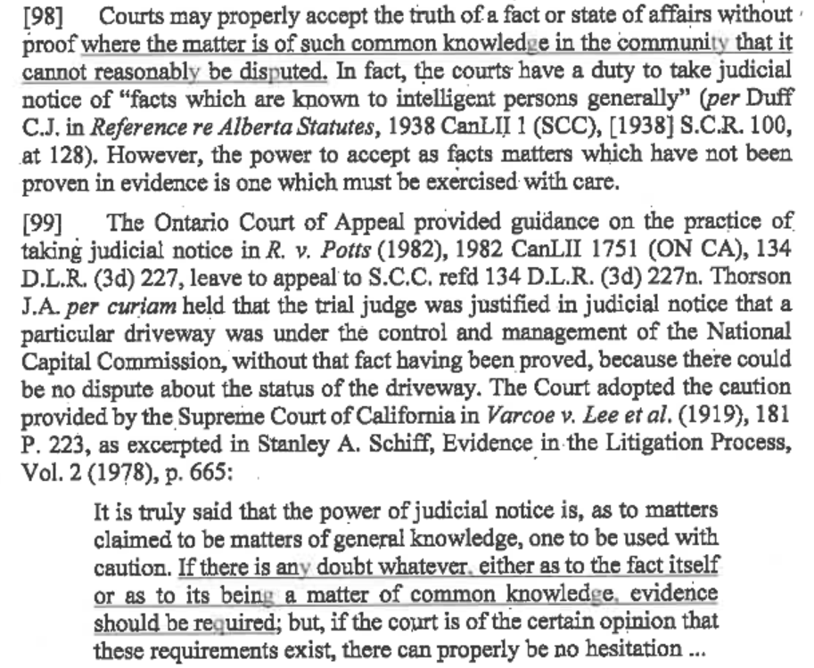
- Admissions (the parties may agree that certain facts are agreed and present these admissions to the Court, in which case evidence need not be called to prove these facts).
- Parties can and do routinely enter into Agreed Statements of Fact.
- Parties can, in advance of litigation, serve the opposing party with a Notice to Admit under Rule 7-7(4). If not responded to within 14 days, the statements of fact and the authenticity of any documents itemized and attached is deemed to be admitted. A party can deny the truth of a fact, but they cannot do so unreasonably without cost consequences. See: Ceperkovic v. MacDonald, 2016 BCSC 939, at paras. 38 and 43:
In summary, the failure to admit the truth of a fact may be unreasonable within the meaning of Rule 7-7(4) if:
(a) the truth of the fact is subsequently proved;
(b) the fact was relevant to a material issue in the case;
(c) the fact was not subject to privilege;
(d) the notice to admit was not otherwise improper;
(e) the notice to admit was reasonably capable of evaluation within the time required for response; and
(f) the refusing party had no reasonable grounds for believing that it would prevail on the matter.
…
[43] While the cost consequences of an unreasonable failure to admit are usually confined to the costs of proving the truth of facts or the authenticity of documents, the power conferred by Rule 7-7(4) to penalize a party by awarding additional costs or depriving a party of costs “as the court considers appropriate” suggests that in an appropriate case the court could go further. At the least, it is not outside of contemplation that if the entire trial could have been avoided had reasonable admissions been made (for example, if the originating party could have applied for judgment on admissions under Rule 7-7(6)), the party who unreasonably failed to admit the facts could be penalized by an award of additional costs for all steps taken following delivery of the notice to admit.
Witnesses
- Witnesses, what they have to say, and how they say it are critical to the outcome of any trial. A case is only as good as its facts, and the facts are usually solicited from the witnesses.
- Scheduling of witnesses
  - Logical sequencing: telling the story is important.
  - Logistics: witness availability can be a challenge.
  - The court has been critical of plaintiff’s counsel who do not call the plaintiff as the first witness. For example, see Gustafson v. Davis, 2012 BCSC 1576, at paras. 114:
[114] Counsel has the responsibility to present his case as he sees fit and the court understands if obstacles are created by scheduling difficulties for expert and out of town witnesses, or other unavailability. However, from the point of view of a trier of fact, it is not only frustrating and even confusing to listen to evidence without a context, it can have an impact on the value of all of the evidence.
[115] The practice of calling the plaintiff first is longstanding and is a common theme in advocacy texts for reasons that resonate with, and are often written by, trial judges. I refer, for example, to § 25.8 of Fraser, Horn & Griffin, The Conduct of Civil Litigation in British Columbia, 2nd ed. (Markham, Ont: Lexis Nexis Canada Inc., 2007):
Unsurprisingly, if a plaintiff is called as the first witness for his case, he tends to have more credibility than if he is called as the last witness, because of his opportunity, in the latter situation, to tailor his evidence to the evidence of the witnesses who have gone before him.
and to s. 8.20 of the British Columbia Civil Trial Handbook, 2nd ed. (Vancouver: The Continuing Legal Education Society ofBritish Columbia, 2005):
In many cases the plaintiff will be called first, such as in a non-catastrophic injury case or a family case. One reason for this choice is that the decisionmaker usually wants to see the plaintiff to get a sense of the case, and may pay less attention to other witnesses if impatiently awaiting the plaintiff.
and to Donald S. Ferguson, ed., Ontario Courtroom Procedure (Markham, Ont.: Lexis Nexis Canada Inc., 2007) at p. 815:
It is common for counsel to call their party as their first witness to avoid any submission that the party may have tailored his or her testimony to that of other witnesses.
[116] If persuasion is the objective, and if it rests largely on the credibility of the plaintiff, counsel might give consideration to the practical and sensible course suggested by experience and this common sense advice.
How a witness testifies:
- Logistics – takes the stand when called, sworn or affirm, then sits down in witness box.
- Examination in chief or direct examination begins.
- Cross-examination follows.
- Re-examination if necessary.
How do witnesses fit into the theme of the case?
- Tell the story.
- Elements of the claim that need to be proven.
- Collateral witnesses are especially important if the plaintiff has a limited capacity to tell their story.
- You do not need to call all “witnesses” that you interview. Be strategic. Avoid redundancy.
- The limits of lay evidence – a review of the law of evidence including the prohibition against hearsay, oath helping, and no opinion evidence unless properly qualified as an expert (of which notice must be given).

- The limits of expert evidence – must provide written opinion in advance (84 days if it is a primary report, 42 days if responding) and, in direct, testimony is limited to an explanation of the technical terms in their report.

What are the elements of the case that you have to prove?
- Liability
- Causation
- Injury
- Damages
Who are the witnesses you may want to call in order to prove those elements?
- Liability
  - Plaintiff
  - Eye witnesses
  - Police officer or emergency attendants.
  - Engineer or technical scientific expert.
- Injury
  - Plaintiff
  - Medical experts
  - Treatment providers (physio, OT, massage therapist, kinesiologist)
- Damages
  - Plaintiff
  - Collateral witnesses (family members, friends, co-workers, colleagues)
Adverse Witnesses
- The Rules allow a party to call a witness who is “adverse” in interest.
- Plaintiff would rarely call a defendant as an adverse witness. You only do this where you are worried that the defendant will not call that witness and you need evidence from that witness to prove part of your case.
- Questioning of an adverse witness is akin to cross-examination.
Documentary Evidence

- Err on the side of caution: do your homework in advance, amend your list of documents as soon as you are aware of a new relevant document, and disclose the document before trial: Walker v. Doe, 2012 BCSC 1091
      - Jury trial in an MVA action – Plaintiff motorcyclist alleged he was struck by a tire from the vehicle of an unknown motorist.
      - During cross-examination of ICBC’s engineering expert, plaintiff’s counsel was about to make reference to two documents that originated in ICBC manuals re: safe handling of motorcycles and proper means of inspecting / fastening tires on vehicles. In a previous case, the expert considered the contents of these manuals to be authoritative.
      - ICBC’s counsel objected.
      - Plaintiff’s counsel said he was unaware of the existence of these documents until the weekend before. Defendant’s counsel did not list the documents either because they were unaware of the existence of these documents.
      - Defendants objected to plaintiff’s reference to these documents because they were not listed.
      - There are 4 factors applicable to the exercise of discretion to admit previously undisclosed evidence (at paras. 13-17):
        - Whether the defendant would suffer prejudice if the use of the documents is permitted.
        - Whether there is a reasonable explanation for the failure to disclose the document in question.
        - Whether excluding the document would prevent the determination of the relevant issue on its merits. (Are the documents probative?)
        - Whether, in the circumstances of the case, the ends of justice require that the use of the document be permitted.
      - Plaintiff’s counsel was permitted to put the documents to the expert.
Other evidence that can be introduced at trial:
- Read-ins from discovery transcripts
  - If the defendant makes admissions at examination for discovery, the plaintiff can “read in” these admissions during the trial proper, and they will form part of the evidentiary record. But be careful not to read-in evidence that is unhelpful to your case! See Duncan v. Mazurek, 2010 BCCA 344, at para. 30:
[30] The defendant, relying on Chetwynd-Palmer v. Spinnakers, [1993] B.C.J. No. 95 (S.C.) and Tsatsos v. Johnson (1970), 74 W.W.R. 315, says that by reading in that discovery the plaintiff adopted and approbated his evidence, and the trial judge is not entitled to reject it and choose a different version more favourable to the plaintiff. I am not convinced those cases go that far. While the plaintiff may be at some risk in reading in such evidence as part of her case, where there is contradictory evidence it is my view that the trial judge must retain discretion to weigh it all in reaching his findings.
  - Direct Examinations
Direct Examination (Examination in Chief) = a party presents their evidence through direct examination of their witnesses.
- Important not to underestimate the impact of direct examination.
- The evidence comes from the witnesses because you are not allowed to “lead” evidence on important aspects of evidence.
- Can lead on non-controversial evidence.
- Must ask open ended questions and the witnesses presents their evidence.
- Counsel facilitates the conversation between the witness and the trier of fact.
- Keep it simple.
Preparing the witness.
- Preparation is essential.
- Preparation means identifying the issues of the case for the witness, helping them understand how their evidence fits into the case, and explaining why they are being called to testify. It also requires reviewing their evidence with them both for direct and cross-examination purposes.
- Review documents that you will introduce through them or that may be put to them.
- Take them to a Court room so they can see where they sit, where counsel stand, where the jury sits, where the judge sits. They can watch a trial to see how it works.
- Must identify for them where they are vulnerable.
- Takes hours of time.
Example:
- What kind of questions will you ask the plaintiff?
- What kind of questions will you ask the plaintiff’s employer?
- What kinds of questions will you ask the plaintiff’s family members or friends?

Organizing the Direct Examination
- Introduce the witness to the trier of fact.
  - Establish context – their background insofar as it relates to the case (ex, family member, friend, co-worker, doctor); how do they know the plaintiff.
- Set the scene
  - Accident
  - Slip & fall
  - Medical negligence
- Damages evidence
    - The plaintiff before and after
    - Injury
      - Diagnosis
      - Treatment
      - Prognosis
    - Impact on all aspects of life
      - Home
      - Recreational, social, etc
      - Work
      - Interpersonal
      - Emotional
- Have a goal then sequence your questions to achieve that goal.
- Lay the foundation for the evidence you are eliciting.
- Be logical.
- Options:
  - Chronological.
  - Dramatic impact.
- Start broad then narrow in.
- Do not lead on important evidence!
- If your witness forgets certain facts, you can exhaust their memory and lead a bit.
- Ex.:
  - What time did the accident happen?
  - Was it in the afternoon?
  - I suggest it was 1:00 pm., does that accord with your recollection.
- Have documents organized.
- In some cases, documents have to be proven through a witness.
- Inoculate the weaknesses? Judgment call.
  - Ex. hurtful info in document – not sure if def will pick it up
  - Ex. surveillance
- LISTEN TO THE WITNESS
  - If their answer is unclear or confusing, ask them to clarify or explain.
  - They might answer > 1 question at once so don’t ask the other question.
  - Unexpected answer. Might have opportunity to speak to witness to clarify

  - Cross-Examinations

Cross-Examination = seek admissions or denials that assist your case.
- Effective cross-examination can have a profound impact on the evidence a witness gave in chief and their credibility.
- Very critical aspect.
- Prepare, prepare, prepare!
- Questions should lead to the answer (yes or no).
  - What time did you arrive?
  - You arrived at 1:00 p.m., correct?
Do you have to cross-examine every witness?
- No. Resist the urge to cross-examine just because.
- Identify the topics or areas that you want to cross-examine the witness on.
- Consider whether the evidence will help your case or injure the other party’s case.
- When do you NOT cross-examine? If the witness’ evidence in direct does not harm your case.
- If there is no evidence that you can get from this witness that will assist your case.
Organization of the Cross-Examination
- Goal – maintain control of the witnesses’ evidence.
- Every question must have a purpose. Every question must contribute to building your client’s case or undermining the opposing case.
- Short – get in, get out. There are exceptions.
- Common error – re-iterating the witnesses’ examination in chief.
- Consider what strategy you need to use?
  - Attract bees with honey
  - Intimidate into submissiveness
  - Don’t forget about the trier of fact
- Sequence your questions to lay the proper foundation to get you to your end goal.
- Be logical. For each question, consider the potential range of answers and where you go from there depending on the answer. Like a decision tree.
- If the person you are cross-examining is a party, use the discovery transcript to help you prepare your cross. If you are asking a question that was covered in discovery, make sure you know their area so you can impeach them if they change their evidence.
- If you have a witness statement for that witness, you can use it to guide your cross-examination. If changes evidence, you can use that statement to impeach their credibility.
- Can also use discovery transcripts to elicit helpful evidence.
- Consider what documents you want to put to that witness and organize them within the context of your cross-examination goals.
- Suppress the urge to ask that last question – it can get you into trouble.
- Do not ask a question that you do not know the answer to unless the answer does not hurt your case either way.
- Browne v Dunn = if you intend to argue a theory or make an allegation, you must put that theory or allegation to the witness to permit them to rebut it otherwise you cannot make the argument.
  - Ex. If the defence is arguing that there are other explanations for why the plaintiff is injured or why they cannot work, they must put those explanations to the plaintiff on cross otherwise they cannot make those arguments in closing.
  - Ex.
    - Not the accident that caused the injury but rather a slip and fall at work (Foster).
    - Did not stop working because of physical restrictions or limitations caused by injury but rather due to interpersonal difficulties at work.
- Make sure you are accurately reciting evidence if you are putting it to a witness. Do not misstate their evidence from direct or other evidence (ex. Statements made to doctors etc).
Scope of Cross-Examination
- In Mazur v. Lucas, 2014 BCCA 19, the BC Court of Appeal confirmed that potential bias is a legitimate subject of questioning in cross (para. 25).
Sometimes cross-examination is all you have
- See McLaren v. Rice, 2009 BCSC 1457

[22] The plaintiff sustained a closed head injury and fractured skull and has no memory of the accident.
[23] The physical evidence at the scene of the accident as described by Cst. Dyson discloses no braking marks on the roadway or any gouges on the roadway in the northerly direction of traffic or in the southbound lanes before the ditch.
[24] There are significant inconsistencies and contradictions between the evidence given by Jacob Rice at trial and prior unsworn statements given by him and prior evidence given under oath. It is, of course, the evidence given at trial that I must assess, and those prior inconsistent statements go to the credibility of Mr. Jacob Rice. I find that Jacob Rice is an unreliable witness and that the inconsistencies and contradictions diminish such weight as his evidence might have had. I find that the events immediately preceding the accident are not clear in Jacob Rice’s mind because he was either asleep or inattentive as the truck proceeded across the oncoming lanes of traffic. There were no brake marks or any indication that evasive action was taken until the truck “hit the ditch”. I find that what Jacob Rice told ICBC in his statement taken on March 8, 2005, is likely what happened:
It was a pull to the left and then, I just hit the ditch and as we hit the ditch, I tried pulling it to the right and it lost control and, and spinning and from there, it just lost control.
(Emphasis Added)
Examples of cross-examination at trial – Uploaded to the KazLaw webpage
- Daljit Singh Dhillon, Uy v. Dhillon, 2019 BCSC 1136
- Archbishop Emeritus Exner in Anderson v. Molon
  - Re-examination
Re-examination = a witness can be re-examined by the counsel who called him or her but the scope of re-examination is limited to points that arose during cross-examination.
- Purpose – to refute or explain evidence brought out on cross.
- Very limited scope to prevent splitting of case by the plaintiff
- Often do not have time to consult with the witness and have to make a snap decision. Can ask the Court for leave to consult but won’t necessarily be given.
- Keep a list of areas you might want to re-examine on then assess how important they are to your case.
- If not important and not confident as to what witness will say, leave it alone.
- Should be approached with caution: do not re-examine your witness if you do not have to.
- Dangerous if you don’t know what they will say.
- Sopinka et al., The Law of Evidence in Canada: “The purpose of re-examination is to enable the witness to explain and clarify relevant testimony which may have been weakened or obscured in cross-examination.”

  - Objections at trial
- The most obvious purpose of objection is the exclusion of improper evidence. Another reason is to prevent an improper manner of questioning.
- Some of the grounds for objecting during direct or cross are:
1) relevance
2) no foundation
3) hearsay
4) leading questions
5) opinions and conclusions
6) repetitive (asked and answered)
7) assuming facts not in evidence
8) misstating evidence/misquoting witnesses
9) speculative
10) argumentative
11) improper impeachment or attack on character.
- Making proper and timely objections is challenging
- Objections must be timely and have a legal basis.
- An effective objection or the failure to make an appropriate and timely objection can change the course or even the outcome of a trial (or an appeal)
- Stand up, make your objection to the judge, and state your basis for it.

  - Reply Evidence
The plaintiff may be permitted to introduce reply evidence, but rarely. Generally only permitted if the defence’s case raised relevant matters that could not have been reasonably anticipated by the plaintiff.

