Law 435C.001 | Personal Injury Advocacy | 2021 Term 2
Professors:  MARC KAZIMIRSKI and SANDRA KOVACS | Tel: (604) 681-9344  Email: mak@kazlaw.ca  Email: sk@kazlaw.ca  Office: 1900-570 Granville Street, Vancouver BC | Mondays 5:00 – 8:00 pm  UBC Faculty of Law  Zoom

WEEK EIGHT: Experts
- TEACHING OBJECTIVES & OVERVIEW
The goal of this week’s class is to learn how to select, instruct, prepare, object to, and cross-examine expert witnesses in personal injury actions.
Readings:
- White Burgess Langille Inman v. Abbott and Halliburton Co. 2015 SCC 23
- Maras v. Seemore, 2014 BCSC 1109
- Crawford v. Osuteye, 2019 BCSC 2336
- Uy v. Dhillon, 2019 BCSC 1136

- EXPERT OPINION GENERALLY
- An expert’s function is to provide the trier of fact with ready-made inferences which the judge and jury, due to the technical nature of the facts, are unable to formulate (Justice Dickson, R v Abbey, [1982] 2 SCR 24 at page 42)
- A court receives expert opinion to assist its understanding of evidence which is beyond the experience and knowledge of the trier of fact
- The expert is asked to assist the court with the technical analysis of certain facts and to provide the court with an unbiased and objective opinion regarding the inference and conclusions arising from these facts
- Expert opinion evidence is more often than not required to prove the true extent of a claimant’s injuries and losses, because a medical-legal expert can comment upon the claimant’s diagnoses, prognoses (will the injuries resolve or are they permanent?), disability (lost earning capacity and lost homemaking capacity), and provide recommendations for treatment (cost of future care).
- Expert opinion evidence is also required to prove a breach of the standard of care in certain kinds of claims, most notably medical malpractice actions or other professional negligence actions. In the absence of a critical opinion from a professional similarly qualified to the defendant, the action will fail.
- Note that in some cases, the court does not require standard of care opinion. See, for example, Uy v. Dhillon, supra, where Marzari, J. noted that she does not require standard of care opinion evidence with regard to commercial truck driving where the negligence alleged is common to all motor vehicle operators.
- SELECTING THE RIGHT EXPERT
- A properly qualified expert must be shown to have acquired some special knowledge through study or experience in respect of what he or she intends to testify on.
- When selecting an expert, it is important to look at the expert’s history before the courts. You may have found the right expert in terms of qualifications, but if he or she carries baggage into the case then it might be a real problem – you must look at their history as an expert before the courts with several questions in mind:

  - Have they been well-received?
  - Have they previously been labelled an advocate?
- If yes to the questions of advocacy:

  - How long ago was the adverse treatment?
  - Have the findings or allegations been reversed or addressed in later appearances before the court?
- EXAMPLE: Fr. Tom Doyle – Canon Law expert in Anderson v. Molon et al. As one might imagine, there are not many Canon Law experts (born and bred within the RCC) who are prepared to speak out against the Church. Tom Doyle is an ordained Catholic priest. He was one of the original whistle blowers within the Catholic Church. He has worked consistently with clerical abuse victims since the 1980s.
- On Day 1 of the Anderson v. Molon trial, we argued the admissibility of his report. We were prepared for allegations of bias. An unreported voir dire ruling from Ontario had previously labeled Tom Doyle an advocate over something outrageous he said in an email from 2000, in which he compared Catholic hierarchy to the Nazis.
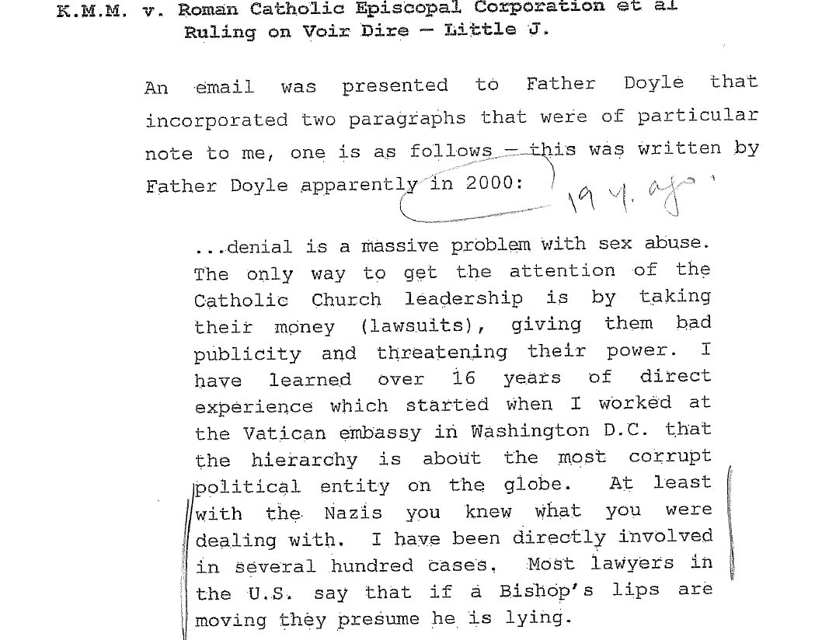
- How do you recover from that? Well, since 2000, Fr. Tom Doyle has been considered by numerous courts, commissions, and grand juries throughout the world, and in 2018 he was relied upon by the NLFD court, and most recently his authority on the topic of historical sexual abuse by clergy was referenced in the SCC. He has been rehabilitated. In Anderson, the court did not redact his report on grounds of bias but rather because he drew legal conclusions that the court found unnecessary because they usurped the jurisdiction of the court.
- Another interesting practice concern arising in the context of motor vehicle injury claims is that ICBC most often uses orthopedic surgeons instead of physiatrists to opine upon soft tissue injuries. There is a reason for this and it has not gone unnoticed by the court. Mr. Justice Saunders’ comments in Khudabux v. McClary, 2016 BCSC 1886 (CanLII), at paras. 92-93, a case where ICBC hired an orthopedic surgeon as per its usual practice:
There is a tendency common to many orthopaedic surgeons who provide expert opinion reports in soft tissue injury cases before this court to express their opinions without qualification – specifically, without acknowledging the extent to which their opinions are shaped by or restricted to the narrow field of their own expertise. In the result, many such reports come before this court that, in substance, say “I have examined this patient, and nothing is wrong with them,” when what is really meant is, “I have examined this patient, and I am unable to diagnose any orthopaedic injury”. Expert witnesses who provide opinions in such stark terms without explicitly stating the limitations of their opinion may, if their opinions contrast with complaints of pain and suffering that are found to be genuine, and are at odds with contrary opinion evidence from another medical expert, risk creating confusion. They may also leave themselves vulnerable to a finding of bias if the unstated limitations of their opinions are not drawn out at trial.
These risks should be avoided through counsel having, in the first instance, selected an expert witness qualified to give opinion evidence in a field relevant to the issues at stake. Counsel should be familiar with the commonly understood scope of expertise held by specialists in that field, and should endeavour to determine whether the expert they have retained shares that understanding. Once the expert’s report has been prepared, counsel should always explore with their expert witness the extent to which their opinion has been shaped, in terms of what is said and what is not said, by any limitations in the witness’ expertise. Lastly, counsel should ensure that any limitations or qualifications in the expert’s opinion are frankly acknowledged in the substance of the report.
- ADMISSIBLE FORMAT
- Rule 11-6(1) sets out the requirements for expert reports to be admissible:
(1) An expert's report that is to be tendered as evidence at the trial must be signed by the expert, must include the certification required under Rule 11-2 (2) and must set out the following:

(a) the expert's name, address and area of expertise;
(b) the expert's qualifications and employment and educational experience in his or her area of expertise;
(c) the instructions provided to the expert in relation to the proceeding;
(d) the nature of the opinion being sought and the issues in the proceeding to which the opinion relates;
(e) the expert's opinion respecting those issues;
(f) the expert's reasons for his or her opinion, including
(i) a description of the factual assumptions on which the opinion is based,
(ii) a description of any research conducted by the expert that led him or her to form the opinion, and
(iii) a list of every document, if any, relied on by the expert in forming the opinion.
[am. B.C. Reg. 119/2010, Sch. A, s. 24.]
- Experts rarely know what’s required for a report to be admissible and have no knowledge of the Rules of Court. They’re not experts in the law regulating the courts, they’re medical or engineering experts, etc. so our job as counsel is to make sure their report is admissible and that they understand that they have a duty to assist the court.
- The single, biggest complaint is that experts often don’t appropriately set out the facts and assumptions that they’ve relied upon.
- Another example: not setting out the authoritative literature research publications that set out their view. They can’t just say “the research supports” this or that opinion because this is untestable hearsay: they must be specific about which authoritative texts they’ve referred to and what portions of those texts they’ve relied upon, and they must use those authorities to help explain how their opinion was formulated.
- “It is not only appropriate but essential for counsel to consult and collaborate with [and not just instruct] expert witnesses in the preparation of expert reports. Counsel must explain to experts their duties to the court, clarify the relevant legal issues, and assist experts in framing their reports in a way that is comprehensible and responsive to the pertinent legal issues in a case.”
Moore v. Getahun, 2015 ONCA 55, at para. 62
- PRIMARY and RESPONSE REPORTS
- Rule 11-6(3) requires that all expert reports be served on every party of record at least 84 days before the scheduled trial date.
- Rule 11-6(4) requires service of all responding reports on every party of record at least 42 days before the scheduled trial date.
- Response reports are not always appropriate but in most circumstances it is helpful to send any primary reports received to your own expert to have them first verbally comment and, if there is disagreement that needs to be addressed, have them prepare a response report for the 42-day deadline.
- While a response report is not strictly limited to a criticism of the methodology of an opposing expert, rule 11-6(4) does not permit fresh opinion evidence to masquerade as answer to an opposing expert’s report.
Luedecke v. Hillman, 2010 BCSC 1538, at paras. 26, 49; citing
Kroll v. Eli Lilly Canada Inc. (1995) 1995 CanLII 1981 (BC SC),
5 B.C.L.R. (3d) 7 (S.C.), at page 9
- Best to reply and consider all facts (including new ones) instead of simply attacking, or the expert runs the risk of being seen as biased. Experts do get incensed by reports on the other side. They want to engage. It’s counsel’s job to calm them down and remind them of their role.
- BUT, they are entitled to defend their opinions. And there is case law that confirms there is a difference between advocating for one’s opinion, and advocating for the party that retained you. The former is permissible, the latter is not.
- OBJECTIONS TO ADMISSIBILITY
The admissibility of a report can be objected to on various grounds.
- Was the report served LATE past the 84-day deadline?
- Rule 11-7(6) provides the Court with discretion to admit if served past 84-day deadline when:
  - New facts have been learned and they couldn’t have been learned with due diligence prior to the deadline;
  - The non-compliance is unlikely to cause prejudice by reason of inability to prepare for cross or by depriving the opposing party a reasonable opportunity to tender evidence in response; or
  - The interests of justice require it. MAANAKI v. HOSSEIN, 2019 BCSC 940
- Are the factual assumptions clearly identified?
- The function of an expert is to provide the trier of fact with ready-made inferences from facts proven at trial. The weight afforded to a report depends on those underlying facts being proven, thus the reasons for the expert’s opinion must be stated clearly and succinctly. Where deficiencies can’t be remedied by redaction, the whole of the report may be inadmissible.
- Is the expert assuming the role of an advocate and purporting to make findings of fact?
- The whole report may be deemed inadmissible – this is a rare order but arguing this point is an opportunity to highlight bias before the expert ever attends for viva voce evidence.
- Does the language suggest conclusions that come to close to the conclusions that are for the trier of fact to make?
- I.e., this resulted in some redactions in Fr. Tom Doyle’s report – said the Bishop was “negligent” – deemed unnecessary b/c this is the trier of fact’s role.
- Is the witness unable or unwilling to fulfill the duty to be fair, objective and non-partisan?
- Are the reports duplicate opinions from the same medical specialty? Technically allowed – Voith, J. in Crawford v. Osuteye, the defendant engagted two psychiatrists supporting her standard of care.
There is a two-step analysis required to assess the admissibility of expert evidence. The first step, or threshold requirements, are the four factors set out in R. v. Mohan, 1994 2 SCR 9: relevance, necessity, absence of an exclusionary rule, and the need for the expert to be properly qualified. The second step is a “discretionary gatekeeping step” where “the judge balances the potential risks and benefits of admitting the evidence in order to decide whether the potential benefits justify the risks”.
White Burgess Langille Inman v. Abbott and Halliburton Co.
2015 SCC 23, at paras. 18-24
While the Mohan criteria should be applied by treating the expert report as a whole, the court may exercise the discretion to redact passages of a report that are inadmissible. This depends on the report itself and the extent to which any admissible portions can be disentangled from the admissible portions.
Level One Construction Ltd. v. Burnham, 2017 BCSC 2470, at para. 25
Passages from an expert report are properly redacted where the language suggests conclusions that come too close to the conclusions that are for the trier of fact to make.
Paur v. Providence Health Care, 2015 BCSC 1008, at para. 34
If a witness is clearly unable or unwilling to fulfill the duty to be fair, objective and non-partisan, the expert witness’s report should be excluded at the threshold stage of the analysis. Anything less than clear unwillingness or inability should be taken into account in the overall weighing of cost versus the probative value of receiving the evidence.
White Burgess, supra, at paras. 32, 35, 40, 45-49
Where an expert assumes the role of an advocate and purports to make findings of fact, the whole of the report may be deemed inadmissible.
Maras v. Seemore, 2014 BCSC 1109 (CanLII), at para. 84
In Maras v. Seemore Entertainment Ltd., supra, Abrioux J. engaged in a comprehensive review of the legal principles relative to the admissibility of expert reports, including the applicability of the Mohan principles, accepting that a trial judge must be particularly cautious in exercising the gatekeeper function if the trier of fact is a jury (at para. 20). At a hearing considering the admissibility of expert evidence, the question is whether the expert’s evidence is sufficiently reliable to merit consideration by the trier of fact (at para. 19, citing Beazley v. Suzuki Motor Corporation, 2010 BCSC 646 at para. 14).
Maras v. Seemore Entertainment Ltd., supra, at paras. 18-30
It is not only appropriate but essential for counsel to consult and collaborate with expert witnesses in the preparation of expert reports. Counsel must explain to experts their duties to the court, clarify the relevant legal issues, and assist experts in framing their reports in a way that is comprehensible and responsive to the pertinent legal issues in a case.
Moor v. Getahun, 2015 ONCA 55, at para. 62
Where concerns about the admissibility of a report are so broad that the necessary instructions to the jury would be something tantamount to a direction that the jury should give the report no, or at best, very little weight, there is nothing to be gained by burdening the jury with that report.
Anderson v. Pieters, 2016 BCSC 889, at para. 63
- PREPARING YOUR OWN EXPERT FOR TRIAL
- The best way to prepare for cross-examination of the opposing expert is through your own expert: It would be inconceivable not to use your own expert to help you get ready! You’re going toe-to-toe with a smart, sophisticated witness that has more knowledge in the area than you. Same with professional negligence cases – defendants are sophisticated with more knowledge.
- Inconceivable not to use your own expert to help prepare for cross-examination
- You have to become an expert if you’re going to go toe-to-toe with the opposing expert
- Litigation privilege when using your own expert?
  - To extent that the communication (including verbal) could bear upon the substance of the opinions expressed, otherwise privileged files btween counsel and a testimonial expert may be required to be produced
  - Consider instructing an expert to keep segregated files: one that relates solely to the expert’s role as advisor and one that relates to the preparation of the opinion. Conseil scolaire francophone de Colombie-Britannique v. British Columbia (Minister of Education), 2014 BCSC 741
  - Forming an expert opinion and critiquing an opposing one are clearly related processes; shouldn’t assume that efforts to separate file materials will be seen as valid by the courts
- CROSS-EXAMINATION OF THE OPPOSING EXPERT AT TRIAL
Rule 11-7(3) permits a party of record to demand the opposing expert for cross-examination at trial.
Under ss.(4), if an expert has been required to attend for cross by demand and the court is of the opinion that the cross-examination was of no assistance, the court may exercise its discretion to require the demanding party to pay the associated costs, in any event of the cause.
Under ss.(5), a party is prohibited from calling its own expert to testify viva voce about a written report unless the expert’s attendance has been demanded, or simply to clarify terminology.
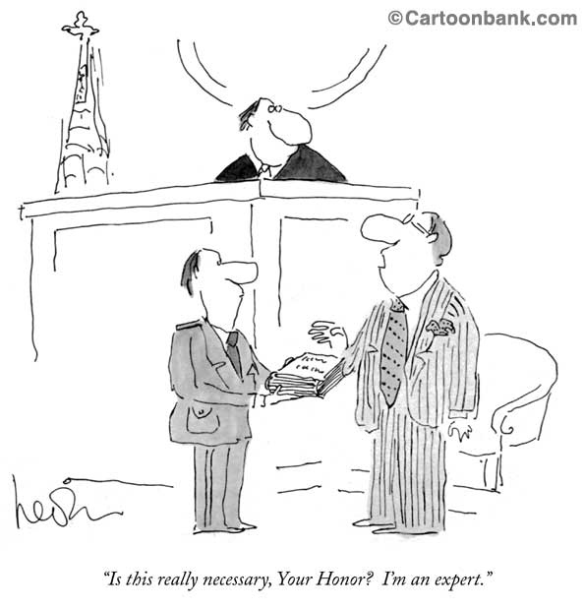
When you cross-examine an expert, there are four main areas where you can have a fight:
- The expert doesn’t have the QUALIFICATIONS: The test for qualifications is low; are they qualified to give an opinion?
- The expert is BIASED: Do they have any of the four traits of expert advocacy?
- The expert DOESN’T HAVE ALL THE FACTS: Sometimes they haven’t cherry-picked; they just don’t know what the case is about
- Lastly, you can POLARIZE THE CASE: Push the Expert’s opinion to the extreme
The expert doesn’t have the QUALIFICATIONS: The test for qualifications is low; are they qualified to give an opinion?
- If there’s a physician, they’re going to have the qualifications.
- The question is whether they have qualifications as good as your expert: Whom should the court prefer?
- In many cases, qualifications will be an important consideration
Expert Dr. P – psychiatrist – jury trial. Dr. P looked older, authoritative. But no leadership positions. And when you look at his CV closely, he was a mature student when he went to med school. So not as many years of experience as one might think. Gillespie on the other hand had been practising since the 1970s, was a president of BCMA, Doctors of BC. I put it to Dr. P that he has only ever been a member of BCMA. Not really relevant to their specific expertise, b/c BCMA is like the CBA for us, but bolsters my own expert’s qualifications while degrading the opposing expert’s.
The expert is BIASED: Is there expert advocacy?
- Does the expert always only represent one side? Are they a cherry-picking expert?
- Do they only hold onto the facts of the side that retained them or do they consider all the facts?
- Do they have a financial interest in the outcome?
- Have they have had previous negative judicial commentary? (Already discussed looking at the expert’s history before the courts in Dealing With Your Own Expert)
- All of this goes to bias and the four traits of expert advocacy
4 TRAITS OF EXPERT ADVOCACY:
- Definition of advocacy: the act of arguing on behalf of a particular issue, idea or person
- The case law considering expert evidence confirms four factors for determining whether an expert has adopted the role of an advocate:
  - Selective experts
  - Expert commenting on credibility
  - Experts and pecuniary interest in litigation – Solomons with ICBC
  - Expert’s demeanor in court
- Dr. Schweigel acted as an advocate for the defendants, not an expert whose sole purpose is to assist the Court. He highlighted all matters that would support the defence position and either downplayed or ignored those that would support the position of Mr. Barnes. Barnes v. Richardson, 2008 BCSC 1349
- Throughout the cross-examination of Dr. Davis, he was argumentative and refused to consider material facts which might detract from his opinion. This is not the proper role of an expert, who must provide an unbiased opinion and consider material facts which are put to him or her.
Grewal v. Brar, 2004 BCSC 1157, citing
Perricone v. Baldassarra, [1994] OJ No. 2199 (Ont Gen Div)
- First, has the expert considered all of the evidence, both positive and negative, and incorporated this evidence into the expert opinion?
- Courts are vigilant in screening experts that deliberately highlight particular aspects of the evidence that support their opinion and exclude or ignore relevant evidence that detracts from their opinion.
- Expert witnesses owe a duty to the court to remain unbiased in their opinions. This duty requires that experts consider all evidence that is provided to them. Selective sampling of the evidence in order to promote the retaining party’s theory of the case will be seen as advocacy and the deemed inadmissible.
- It is a fundamental axiom of our trial process that the ultimate conclusion as to the credibility or truthfulness of a particular witness is for the trier of fact, and is not the proper subject of expert opinion… A judge or jury who simply accepts an expert's opinion on the credibility of a witness would be abandoning its duty to itself determine the credibility of the witness.
R. v. Marquard, [1993] SCR 223 (SCC), citing R. v. Béland, [1987] 2 SCR 398 (SCC)
- The Supreme Court of Canada indicated that a witness's credibility is a proper question for the trier of fact and not for experts.
- The rationale is that issues of credibility do not require the specialized expertise of an expert.
- Where an expert comments on credibility, the opinion will almost universally be interpreted as advocacy and deemed inadmissible.
- Many physicians feel the need to comment on credibility – observed the plaintiff sitting for X minutes, exaggerative behavior, etc.
- “Credibility is within the proper function of a jury … I expect expert witnesses to remain within the boundaries of their expertise and not to artfully craft letters calculated to advance their clients' interests, by suggesting the plaintiff is financially motivated.”
Giang v. Clayton, 2003 BCSC 1236
- Experts may rely on the results of psychological testing when expressing opinions about the validity of the complaints and the extent of injuries. However, here the "diagnosis" of malingering is a comment by the doctor [Wiseman] as to the plaintiff's credibility or reliability as a witness. As such, it is inadmissible opinion evidence.
Brough v. Richmond, 2003 BCSC 512
- [Dr. Hayes’] final opinion or conclusion is simply a statement that there are secondary factors to the plaintiff’s complaints of disability. That is neither a fact nor a conclusion that requires expert evidence.”
Kuhne v. Minifie, 2000 BCSC 1778
- Another area of potential conflict for experts is the issue of pecuniary interest in the outcome of the litigation.

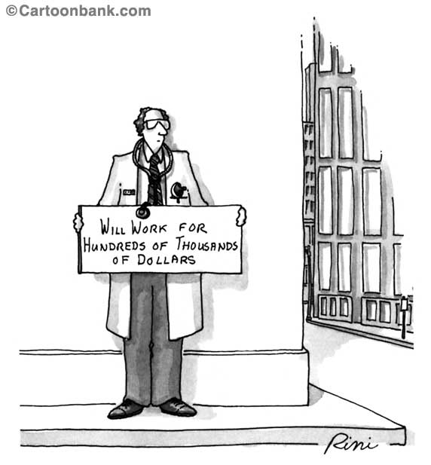
- The courts are increasingly skeptical of expert witnesses with strong financial ties to one party, which while not fatal to the evidence, does often raise an apprehension of bias.
- The concern is that experts are inclined to provide a favourable analysis for the party that pays their fee, particularly, if they wish to be hired again.
- ICBC publishes how much it pays its “suppliers” every year. Despite Mr. Justice Abrioux’s decision, it continues to hire orthopaedic surgeons and pay them a lot of money annually. The following amounts are from the 2017/2018 fiscal year:
  - Dr. Olli Sovio, ortho $314,181 – he’s semi-retired but in previous years he’s billed much more.
  - Dr. Marc Boyle, ortho $528,225
  - Dr. Simon Horlick, ortho $819,991
  - Dr. Kevin Solomons, psychiatrist $877,065 – some years he’s billed over $1m to ICBC
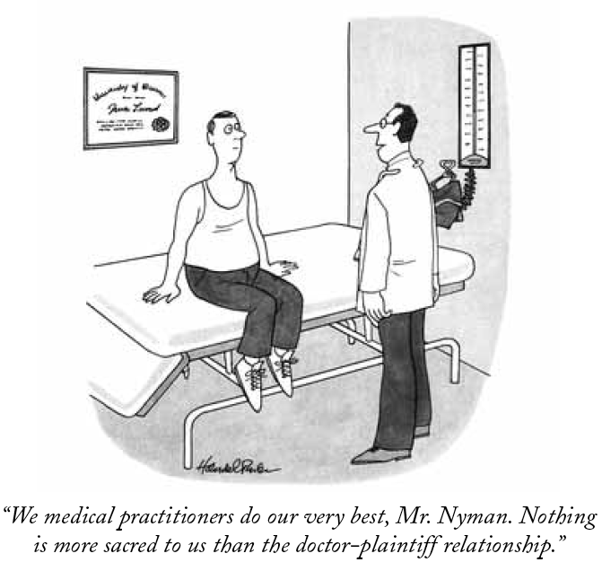
- Treating physicians: “Where the care giver is an expert witness permitted to express opinions there is room for concern over his or her disinterest in the outcome of the litigation. I am not referring to bias or even apprehension of bias. I am referring to…the fact that honest people naturally intensify a little in the direction in which their interests point. This is a matter, then, that affects the weight to be given the evidence of this witness.”
Lee v. Swan, [1996] BCJ No. 259 [BCCA]
- In my view, the suggestion that evidence has been tainted because of motives of economic reward applies not to the plaintiff, but rather, to the defendant's expert, Dr. Fenton. Dr. Fenton has been receiving a substantial amount of referral work from ICBC for many years…These monies were received as payment for the preparation of what Dr. Fenton classifies as independent medical reports, which he says he prepares for the Court. Chiacig v. Chiacig, 2001 BCSC 1709

The fourth factor for assessing expert advocacy is the EXPERT’S DEMEANOR IN COURT
- Experts are expected to be:
  - Professional - Non-partisan,
  - Prepared - Review the file and relevant literature, and
  - Personable - avoid aggressive interaction
  - In Chiacig v. Chiacig, 2001 BCSC 1709 the expert was hostile and combative in cross examination and this behaviour detracted from the expert’s opinion: “I find that Dr. Fenton was argumentative and condescending. His interaction with plaintiff's counsel was akin to sparring, indicating that he was more of an advocate than an independent professional. I give his evidence very little weight.”
- In Shearsmith v. Houdek, 2008 BCSC 997, the expert was ill prepared for court which led to an inference that he was an ICBC hack: “Under cross-examination, it was obvious to me that he had not spent as much time, nor was he as objective, in his assessment of the plaintiff as either Dr. Shuckett or Dr. McKenzie. Dr. Piper impressed upon me that he was more of an advocate for ICBC than an objective expert, and I therefore attach little weight to his evidence.”
The expert DOESN’T HAVE ALL THE FACTS: Sometimes they haven’t cherry-picked; they just don’t know what the case is about
For example, the expert doesn’t have all the facts and is saying that your client is in a state of decline. If you can then show your client is not in a state of decline… Ask:
- If he’s declining, how’s he doing at work?
- At home?
- In his social life?
- Is he working full-time or part-time?
- Is he missing work or showing signs of absenteeism?
You are the master of your client’s facts so you’re on much stronger ground when you can cross an expert on the facts of the case as opposed to going toe to toe with an expert on the science– then you’re on much weaker ground
Lastly, you can POLARIZE THE CASE: Push the Defence’s opinion to the extreme
- E.g.: When you said they were on a downward decline prior to the accident, was it when they were working 60hrs/week before the accident, never having missed a day for 3 years, taking their child to soccer practice when their spouse was sick?
  - Our job is to reveal holes on the other side’s case – you want to make sure you know all these facts
  - E.g. degenerative spine – pre-existing but made symptomatic by an accident
- Push the expert’s opinion to the extreme
- Expert says your client was in a state of decline prior to the accident without having all the facts…
  - “Was this downward decline happening when they were working 60 hours/week?”
  - “Not having missed a day for 3 years?”
  - “While taking care of their child when their spouse was sick?”
Our job: Reveal holes in the other side’s case – Make sure you know all the facts!
- Expert says your client has non-organic findings…
  - “You’re not saying they’re lying or exaggerating, are you?”
  - “No, you’re saying their response to light physical stimulus is not consistent with the damage to the tissues.”
  - “So you’re saying there’s a psychological component??
  - Saying there’s a psychological component ≠ Saying someone is lying
  - Expert says there’s a long list of reasons why your client might have that response – they might be malingering…
  - “Lying or exaggerating when they went to the hospital when they had a head injury?”
  - “How about when their doctor sent them to physio and they went every time?”
  - “Malingering when they started taking antidepressants because they couldn’t function anymore?”
  - “At what point did you opine that they were lying or exaggerating or malingering?”

